**Lab 07 - Building Desktop Application Using JavaFX and Hibernate**

# 1. Introduction

Imagine you're an admin of IT department in a University. Your manager has asked you to develop a web application for Library Department to manage the Student, Book ( A Student can borrow many books)

BOOKS(id, author, isbn, title)

STUDENTS(id IDENTITY(1,1), email, password, firstName, lastName, marks)

The application has to support adding, viewing, modifying, and removing students—a standardized usage action verbs better known as Create, Read, Update, Delete (CRUD).

This lab explores creating an application using Hibernate, JavaFX. An **SQL Server** **Database** will be created to persist the student data (reading and managing) by **Hibernate.**

# 2. Lab Objectives

In this lab, you will:

* Use the **IntelliJ**/Eclipse to create Maven Project.
* Develop application using JavaFX, Hibernate
* Use JPA to Create a SQL Server database named LibraryDB that has three tables: STUDENTS, BOOKS, STUDENTS_BOOKS
* Develop 3-Layer with Repository Architecture to perform CRUD actions using Hibernate and JavaFX.
* Run the project and test the application actions.

# Activity 01: Design the Student Management

**Step 01**. Open Gluon Scene Builder

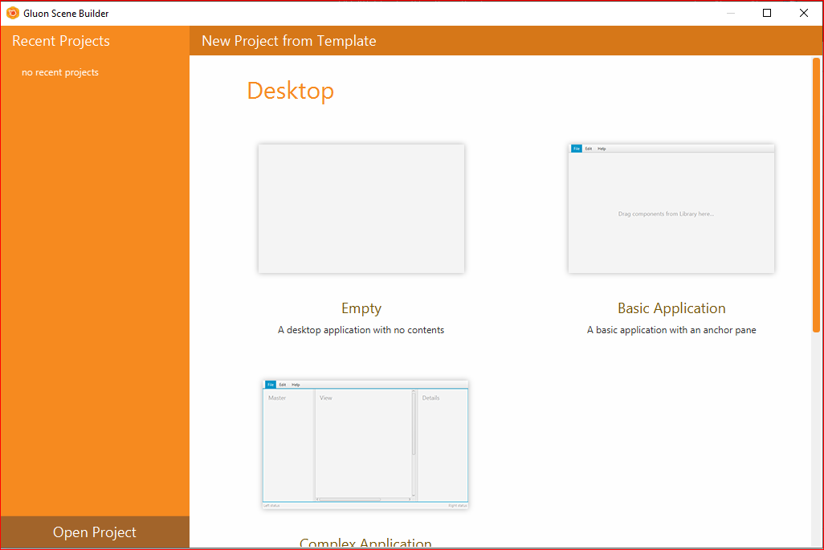

**Step 02.** Design the Manage Student and Login

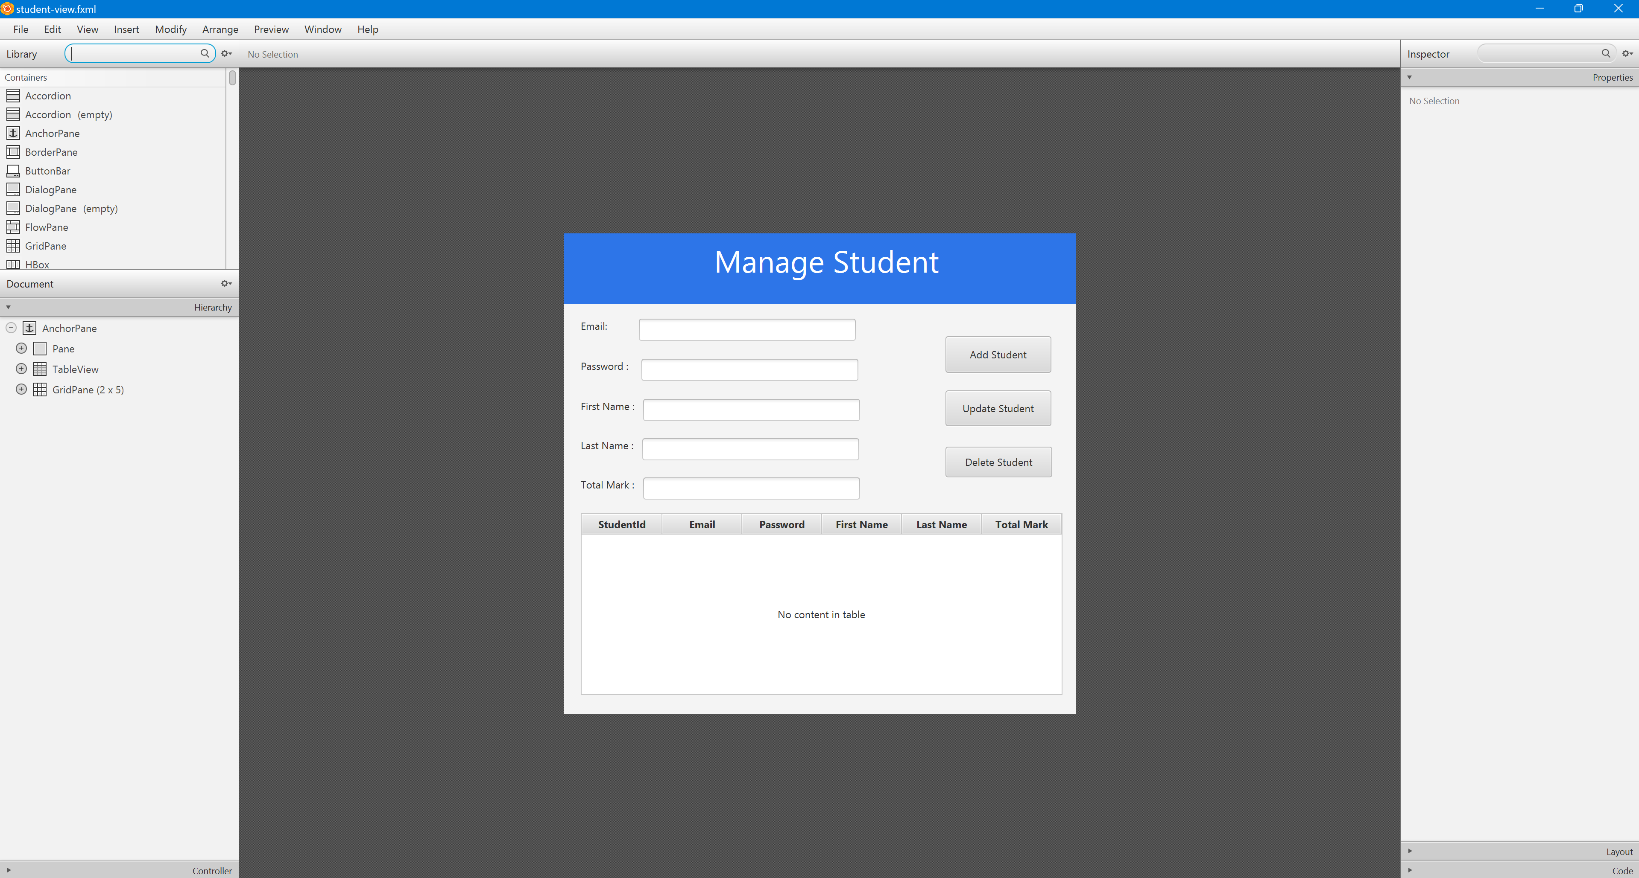

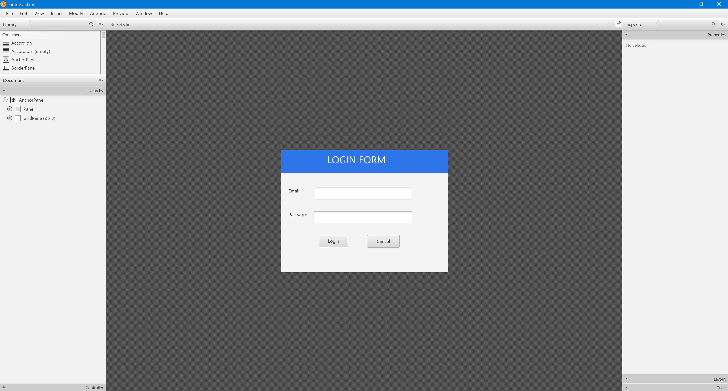

# Activity 02: Develop the Architecture with Repository Pattern and show the Student List

**Step 01.** Open IntelliJ, File | New | Maven Project

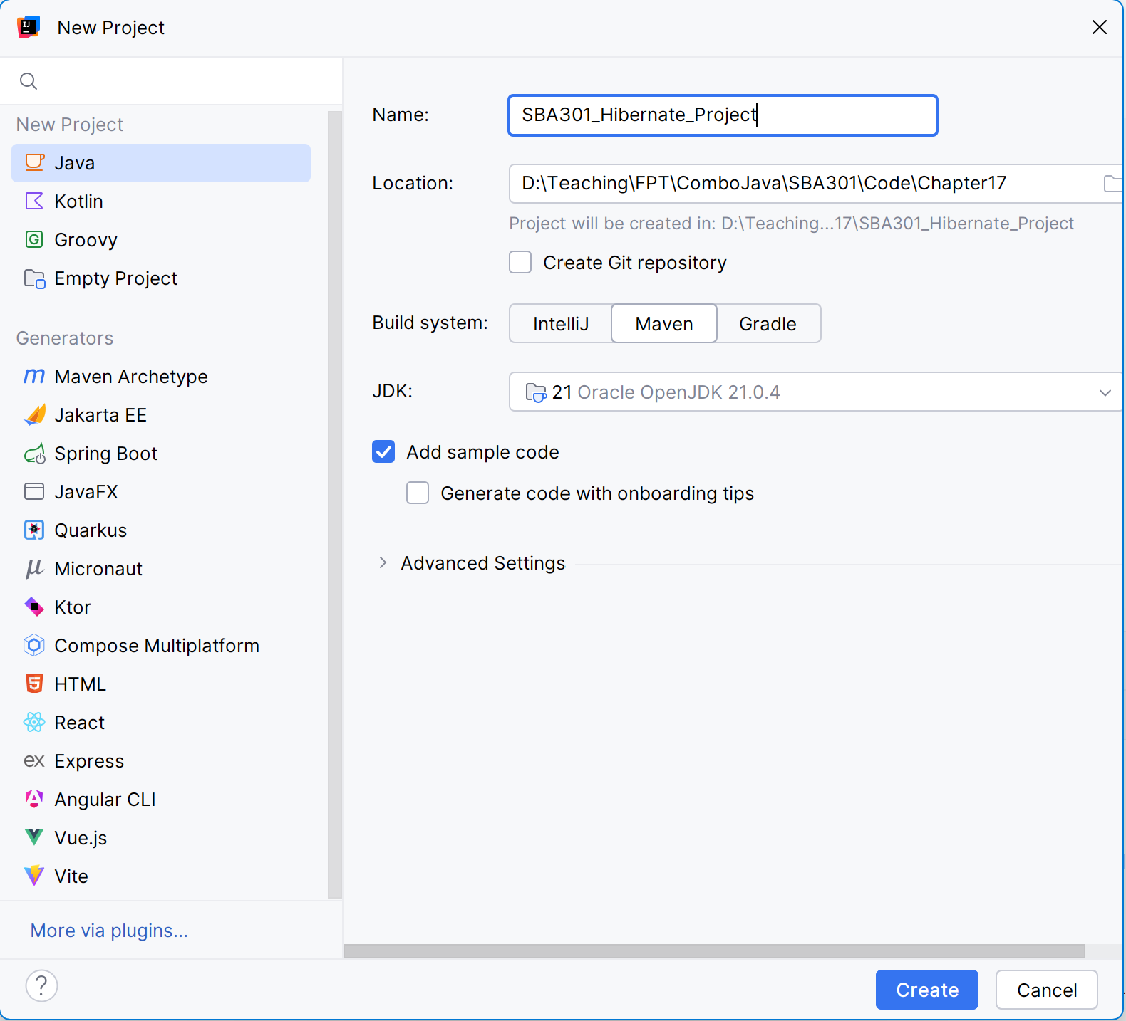

**Step 02**. Structure of Maven Project

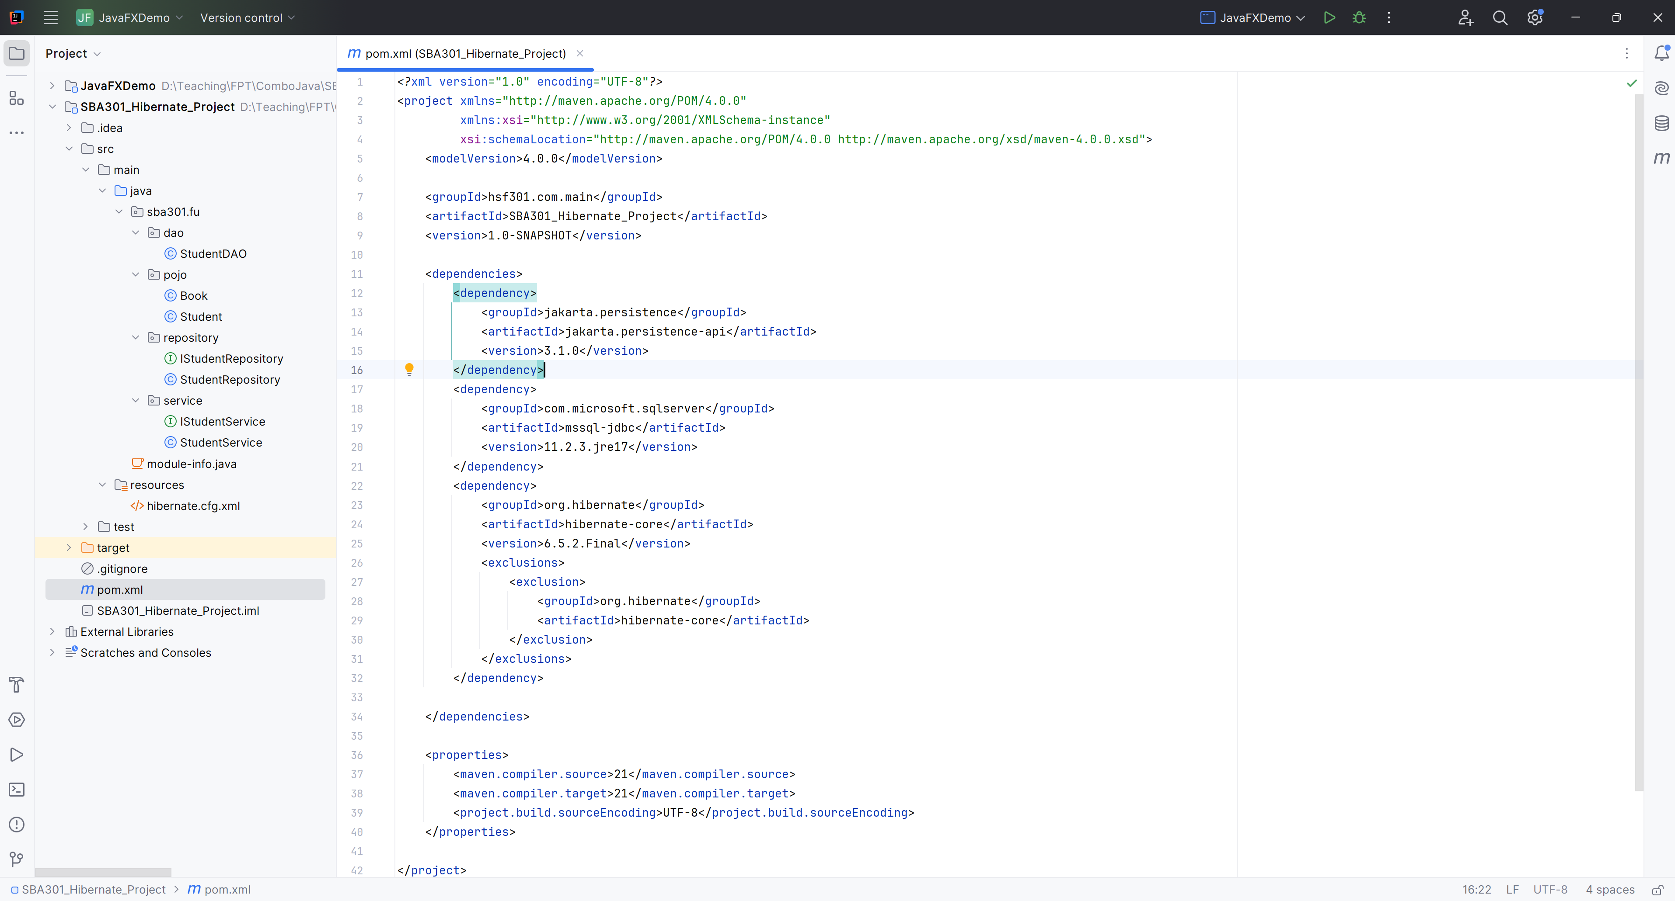

**Step 03**. Create hibernate.cfg.xml

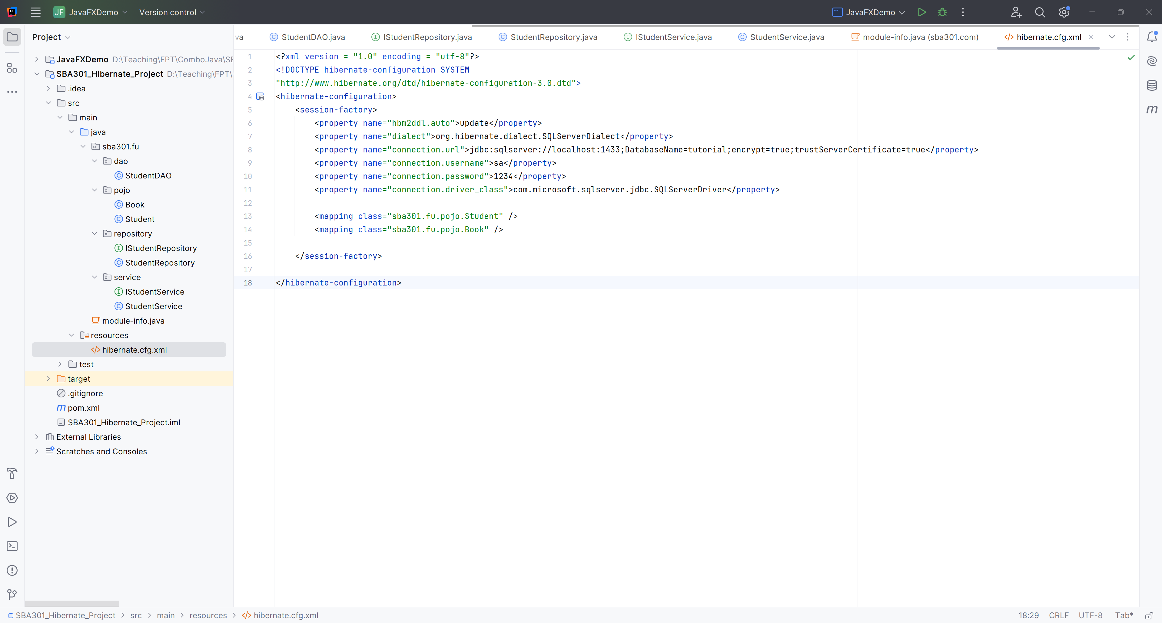

**Step 04**. Create Books in Pojo

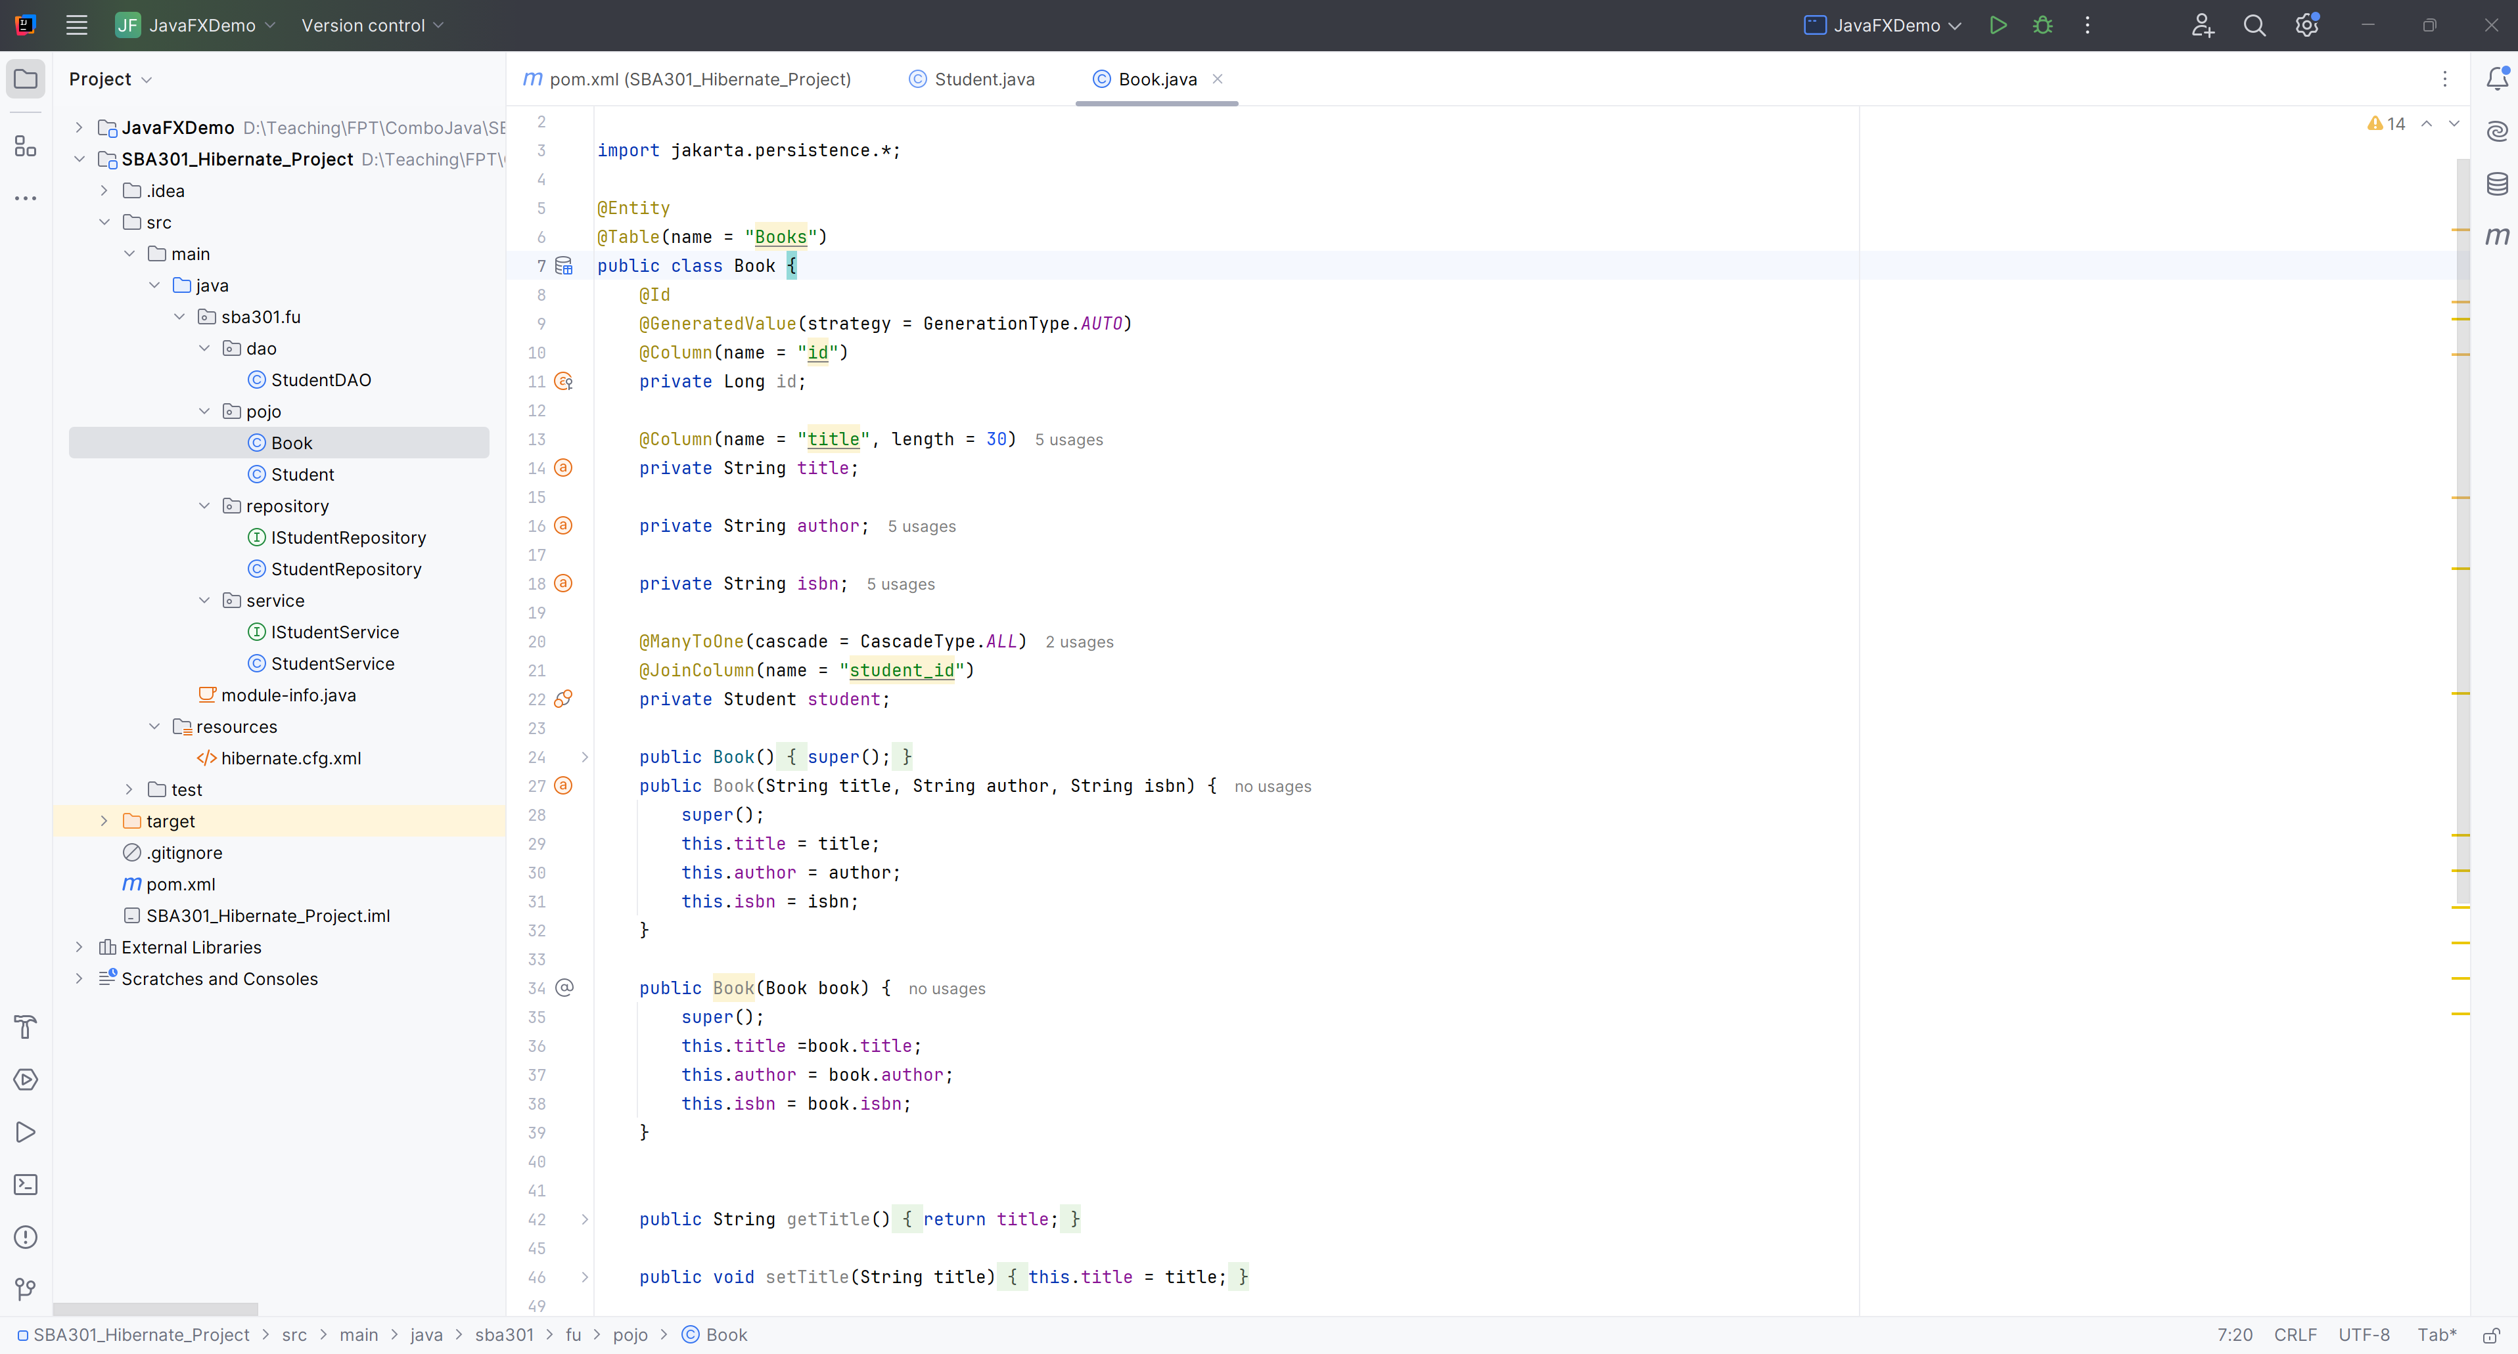

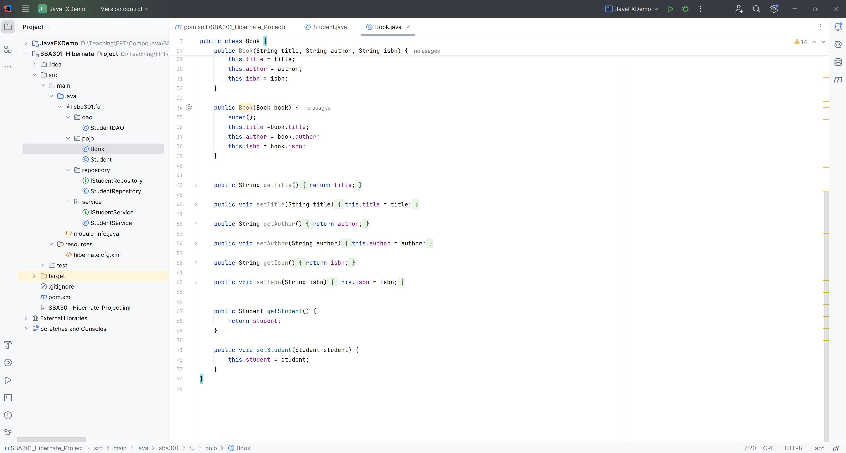

**Step 05**.Create Student in Pojo

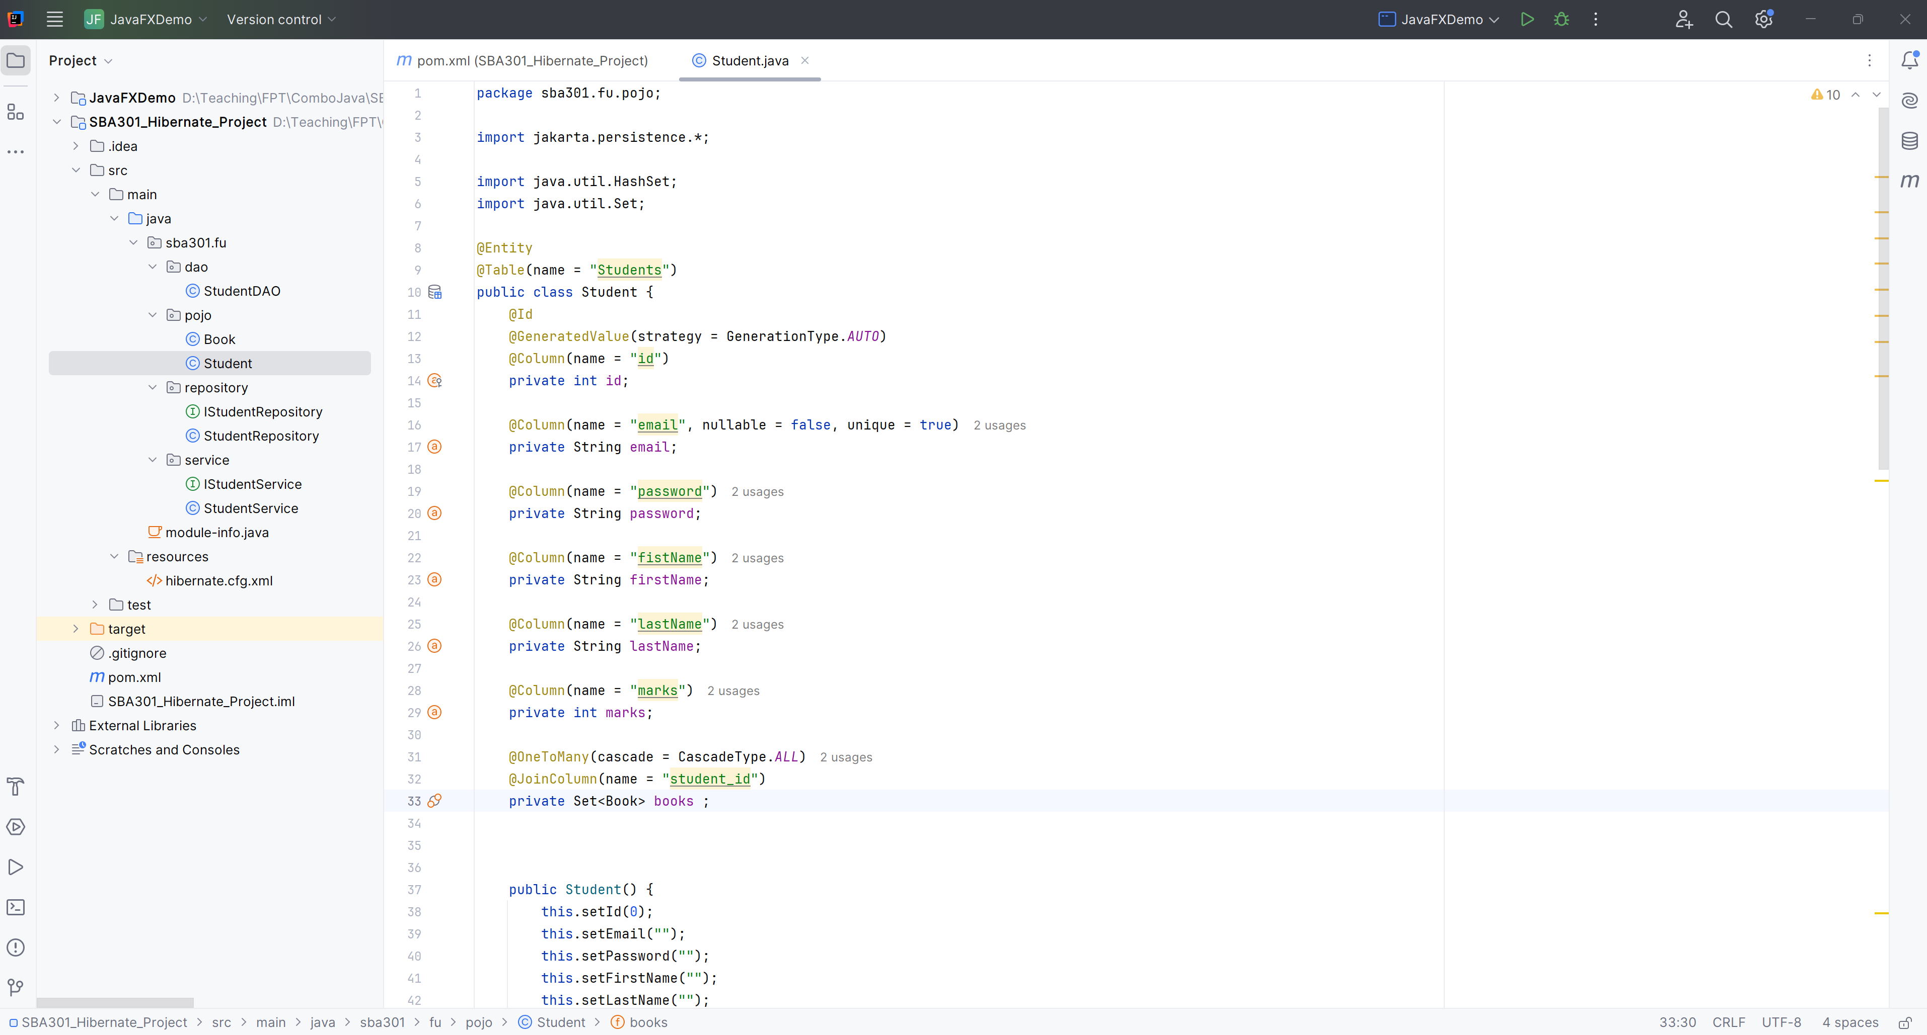

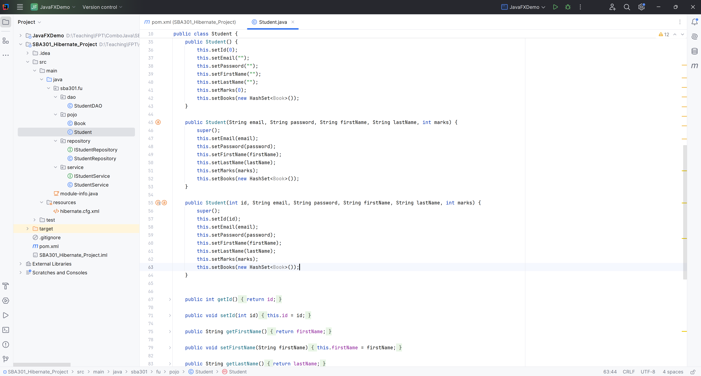

**Step 06**. Create StudentDAO in DAO package

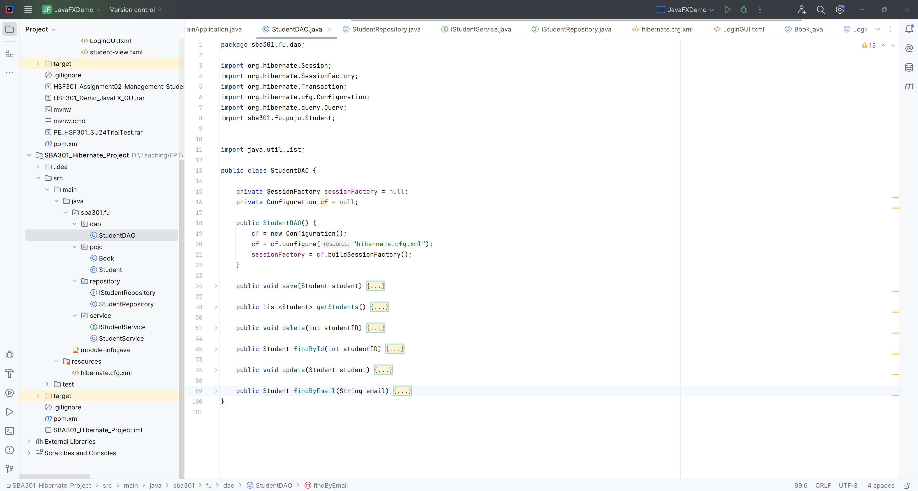

**Step 07**. CRUD StudentDAO in DAO package

* Save Student in StudentDAO

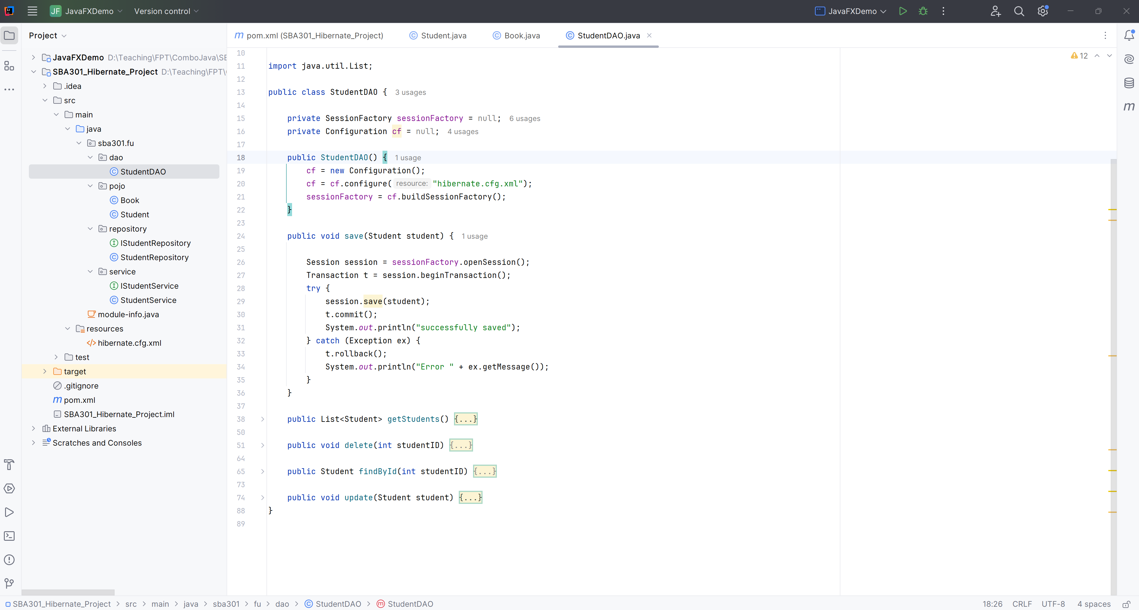

* Get All Student in StudentDAO

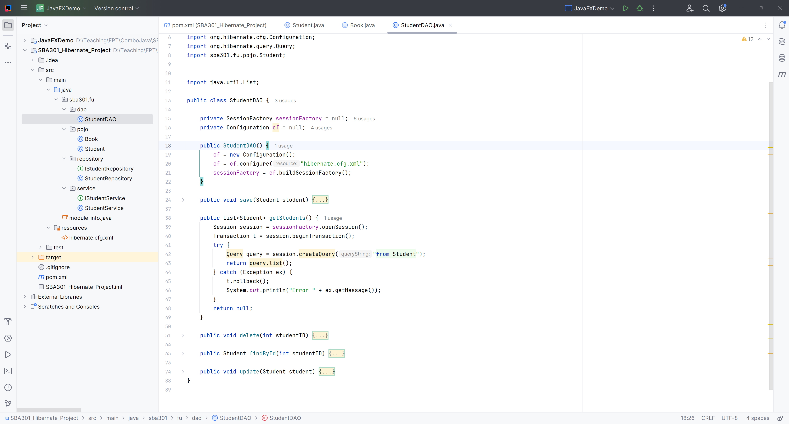

* Delete Student in StudentDAO

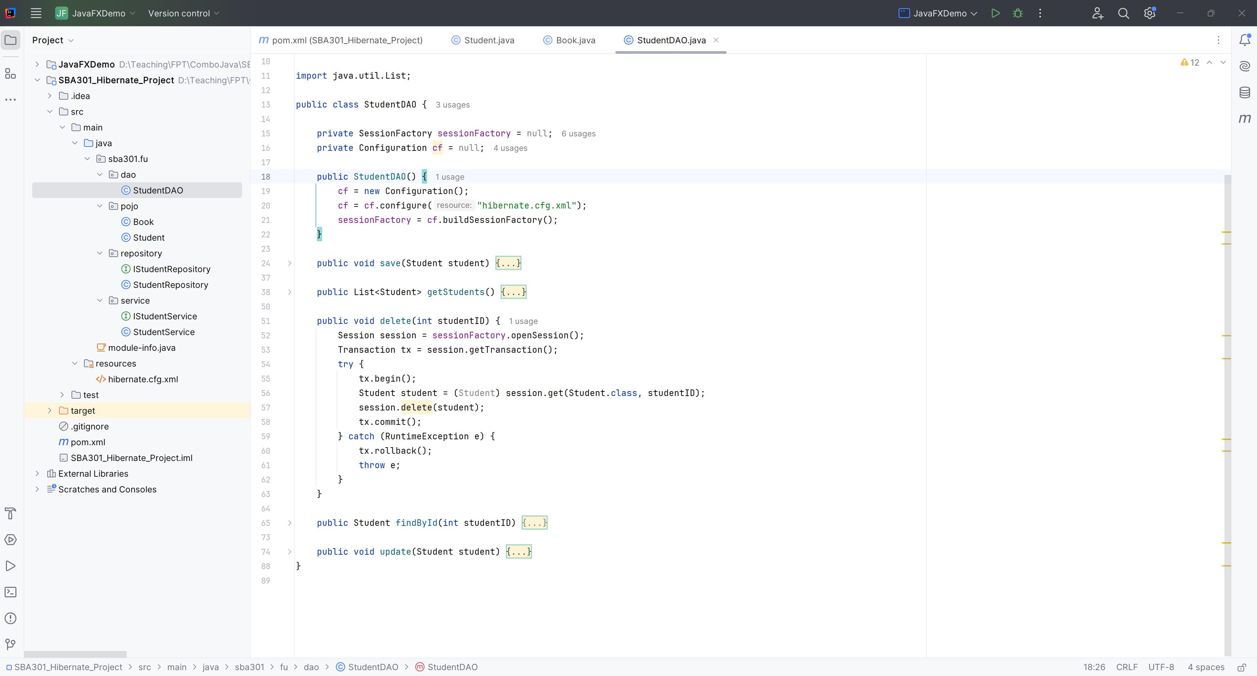

* Find A Student in StudentDAO

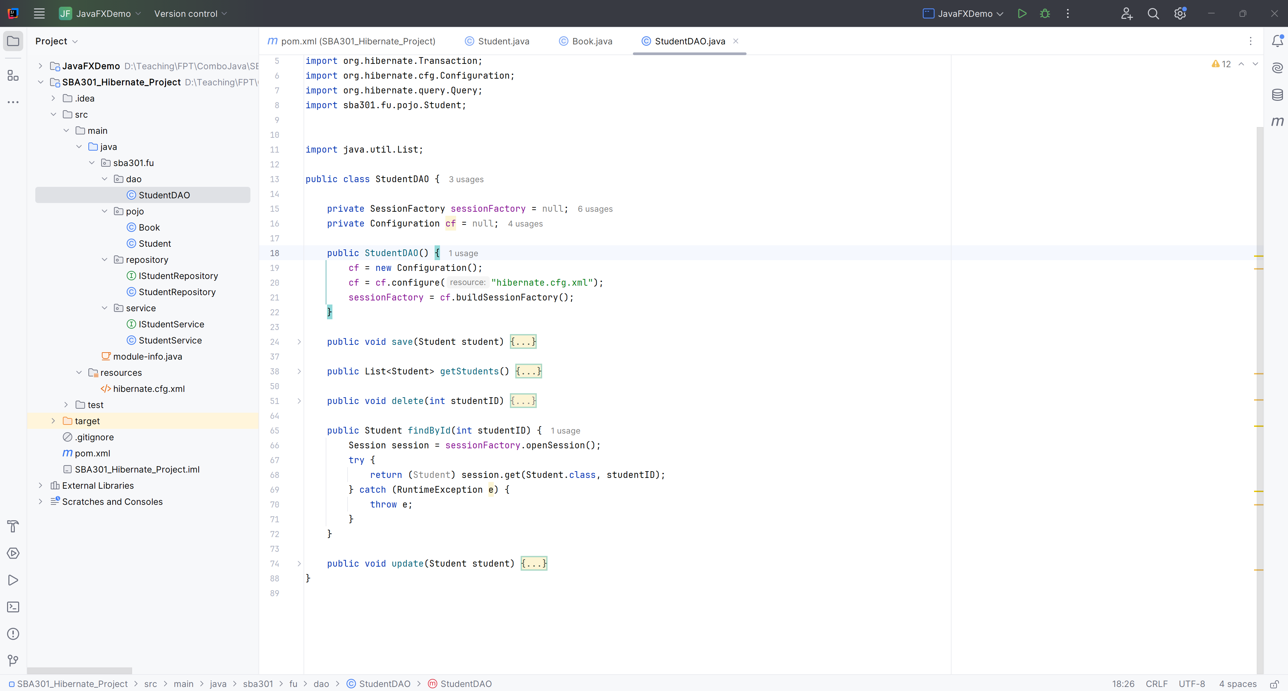

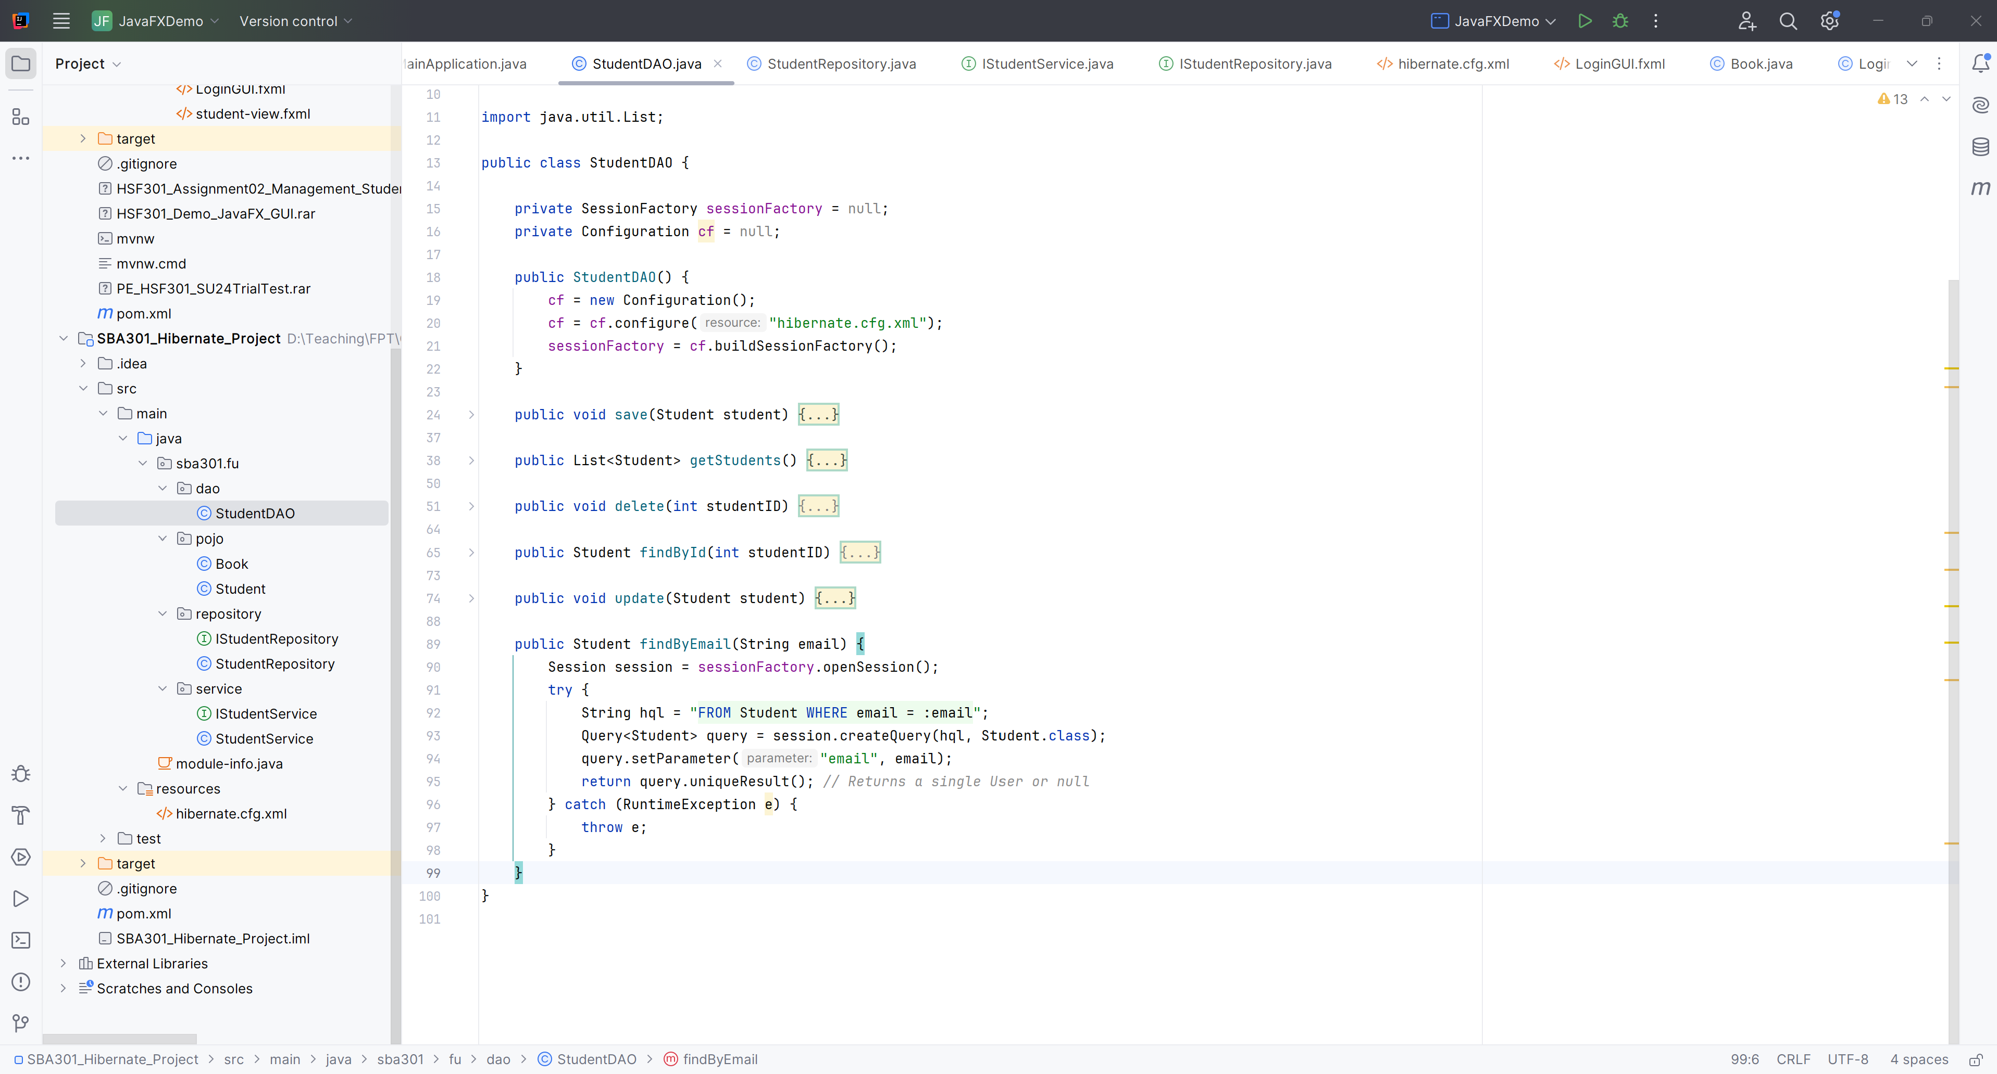

* Update a Student in StudentDAO

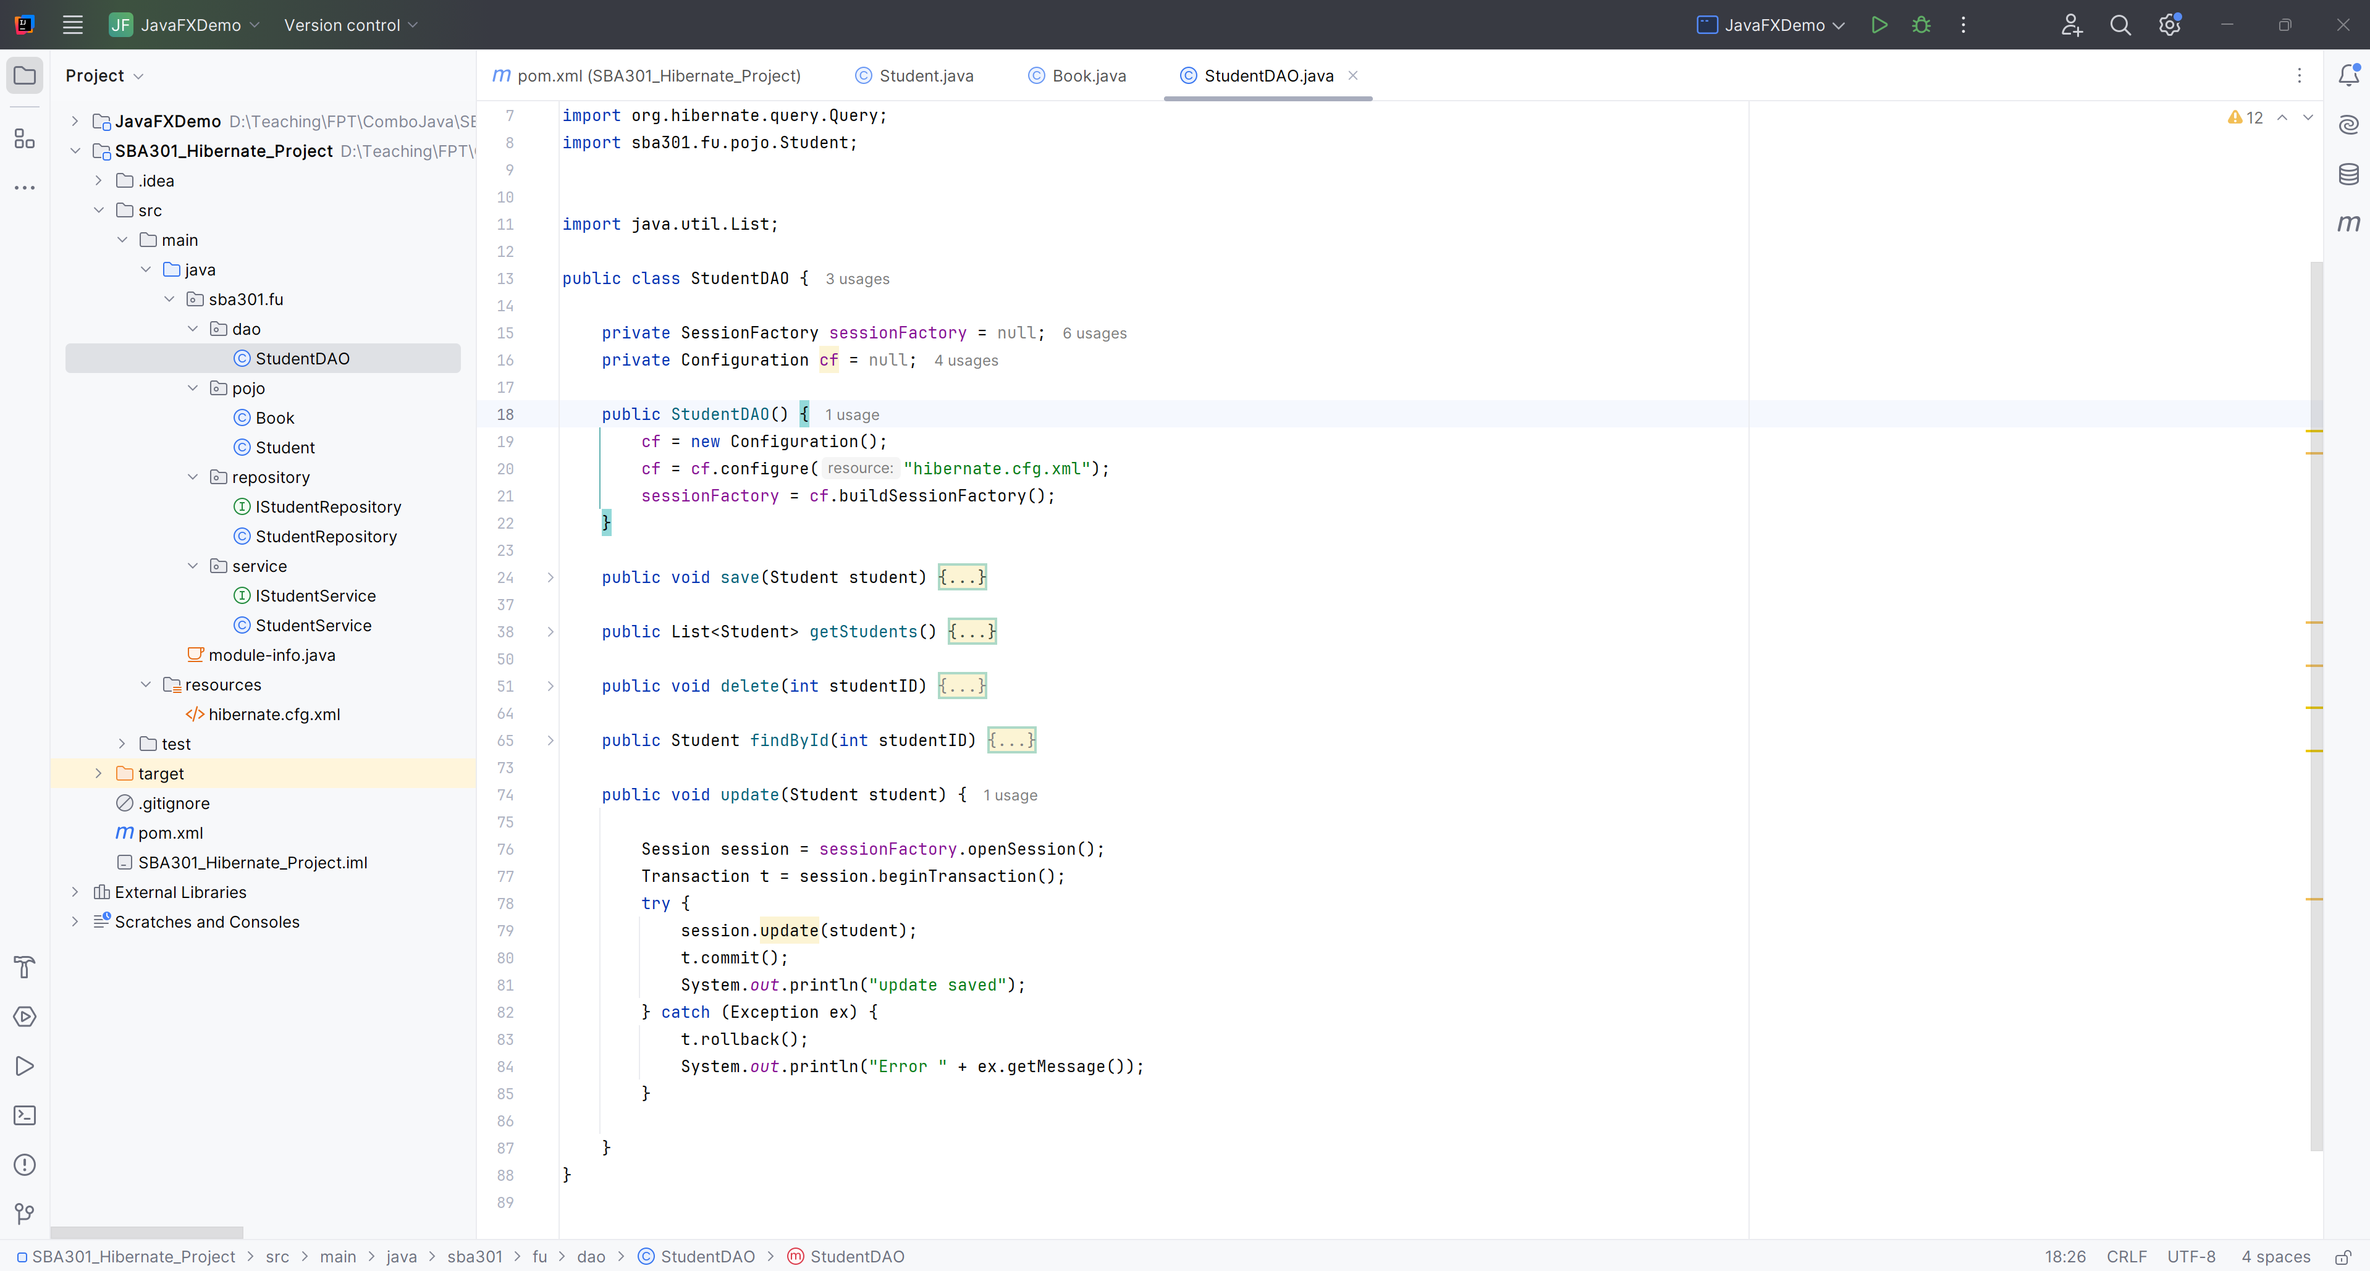

**Step 08**. Create IStudentRepository in Repository Package

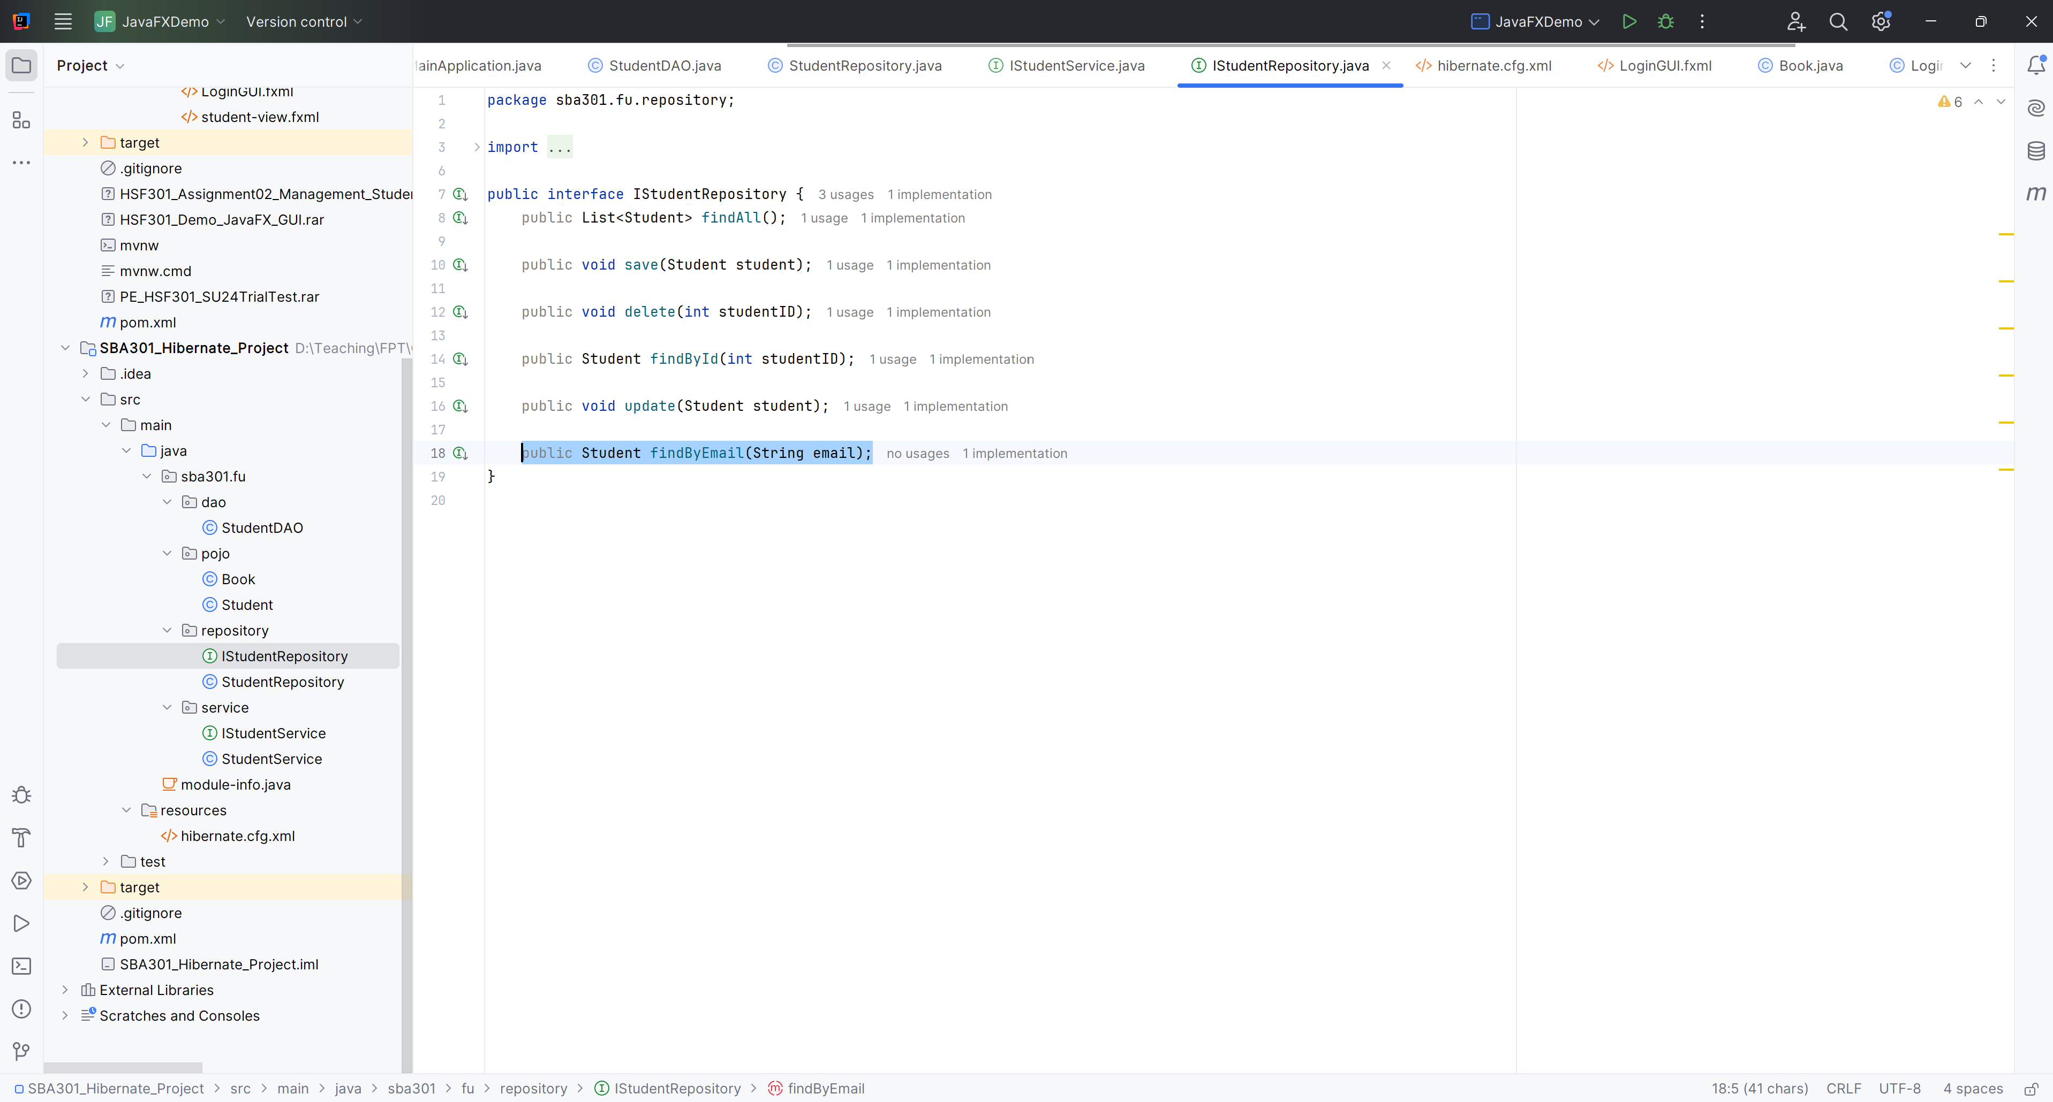

**Step 09**. Create StudentRepository in Repository Package  
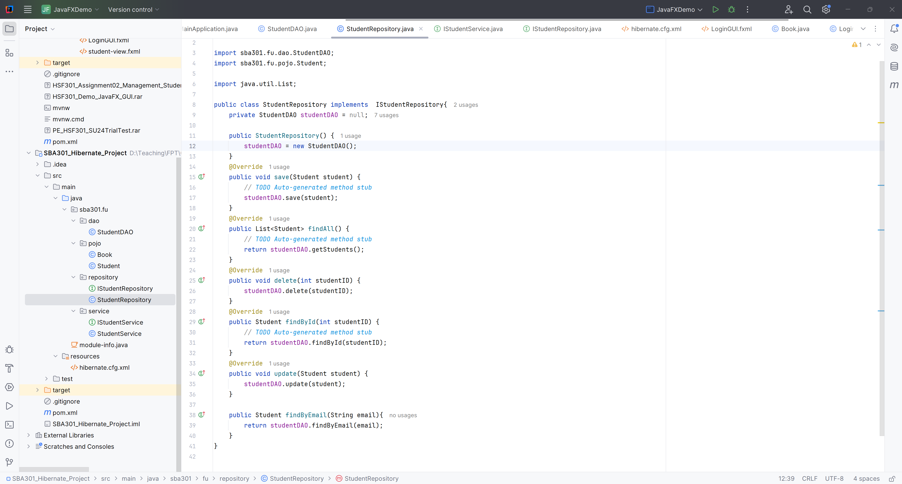

**Step 10**. Create IStudentService in Service Package

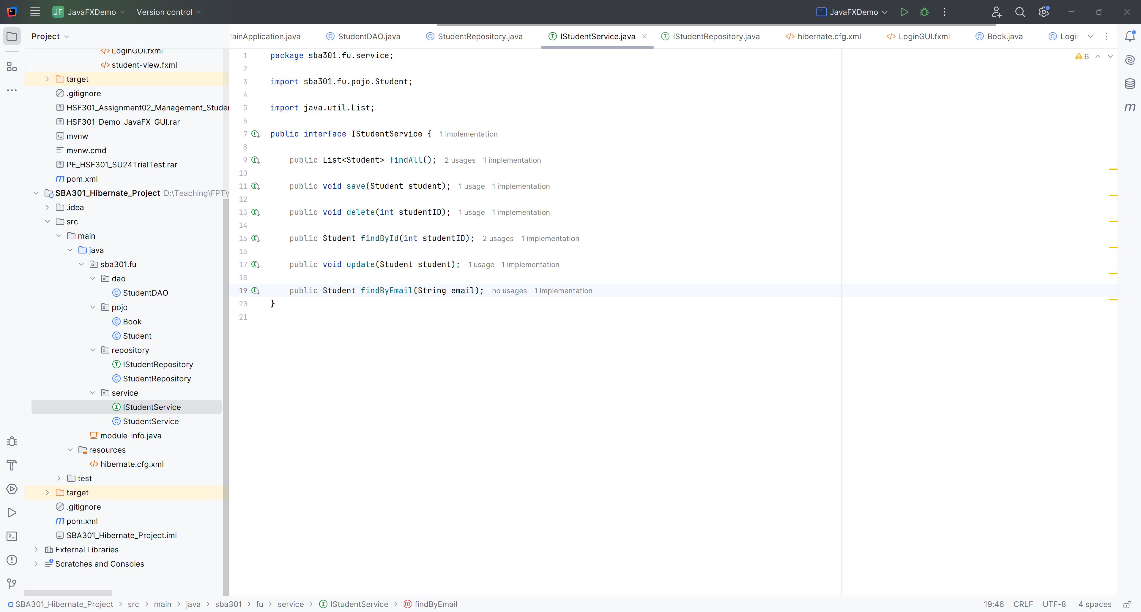

**Step 11**. Create StudentService in Service Package

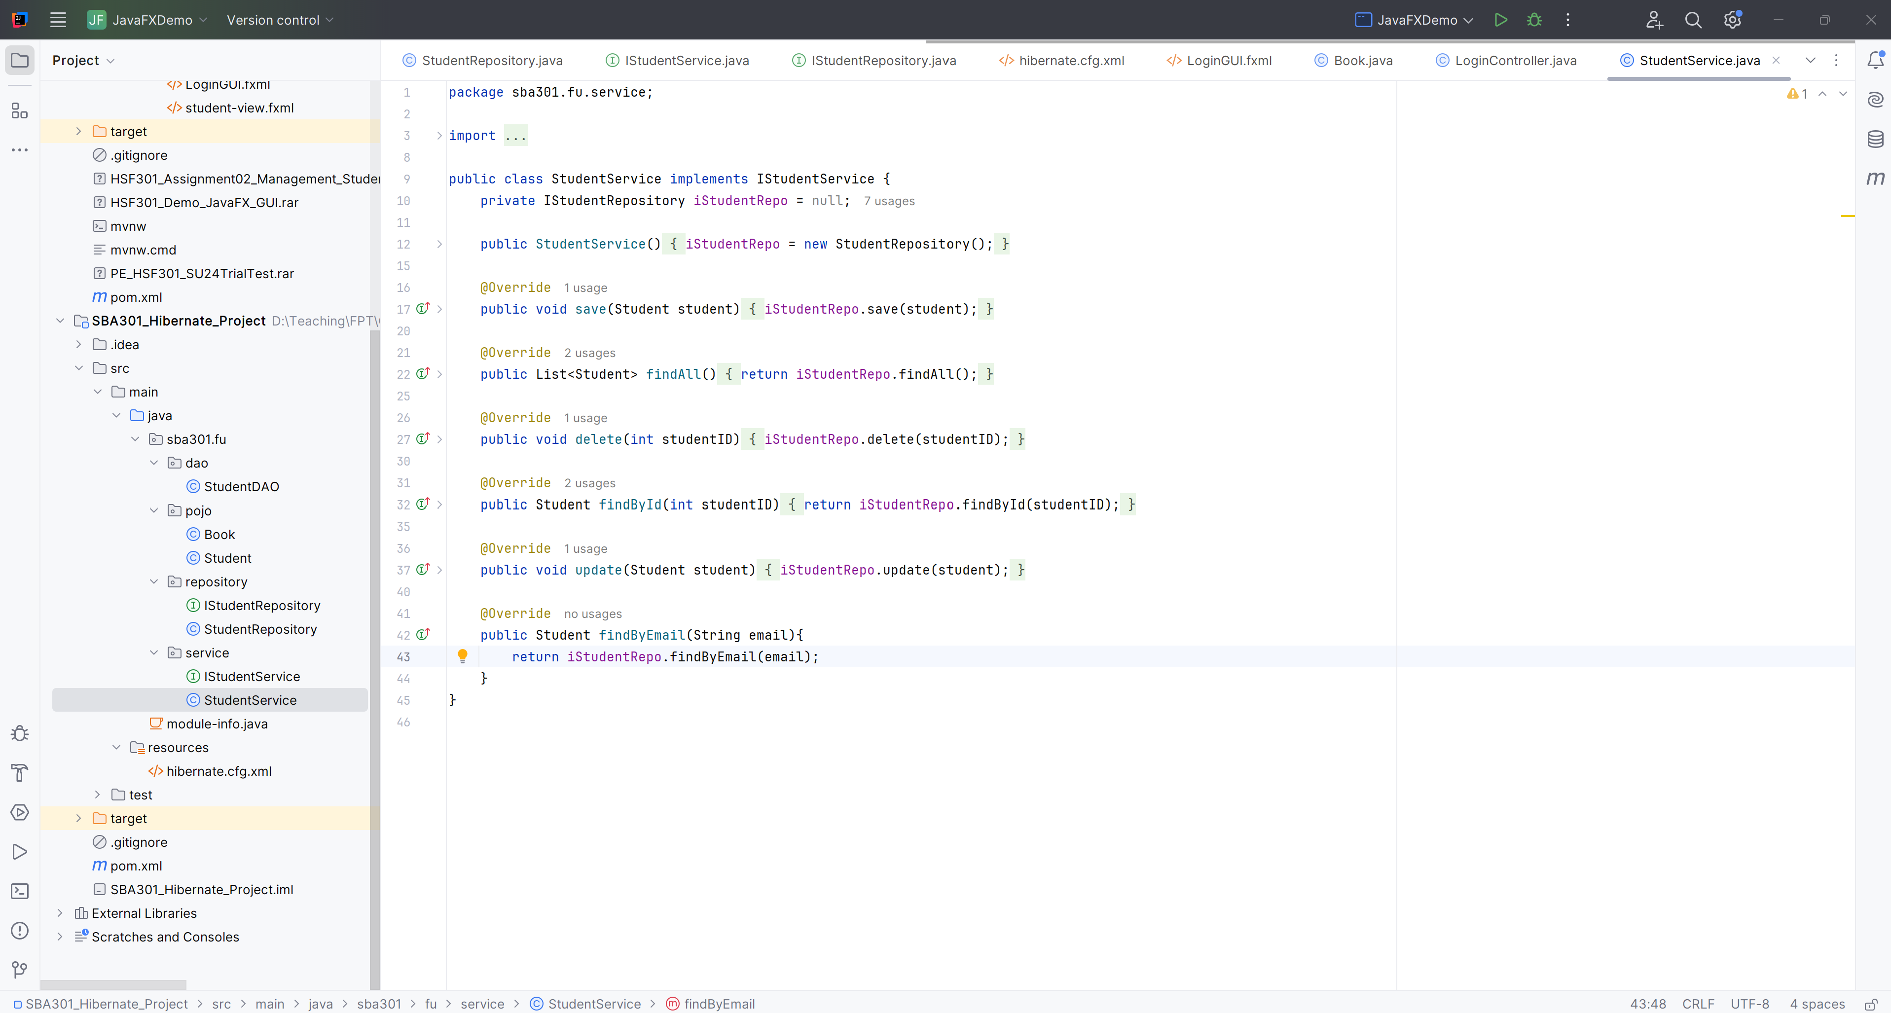

**Step 12**. Create module-info.java

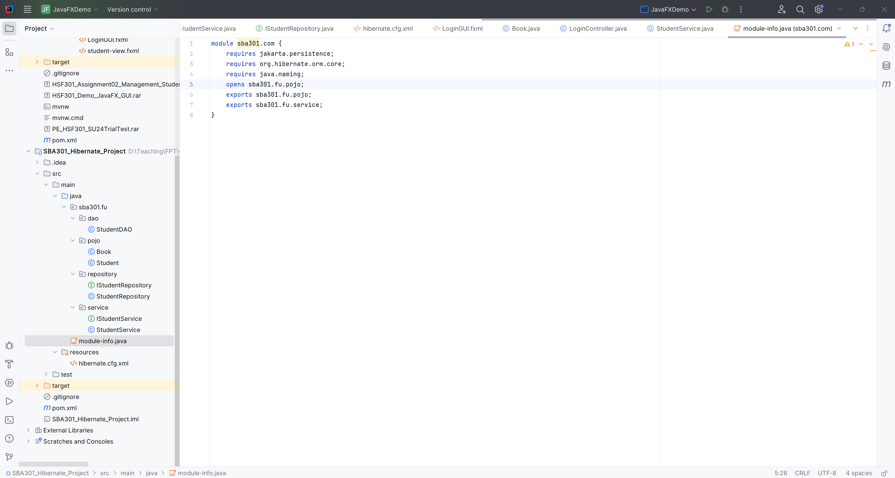

# Activity 03: Develop the Student List Page

**Step 01**. Open IntelliJ, File | New | JavaFX Project

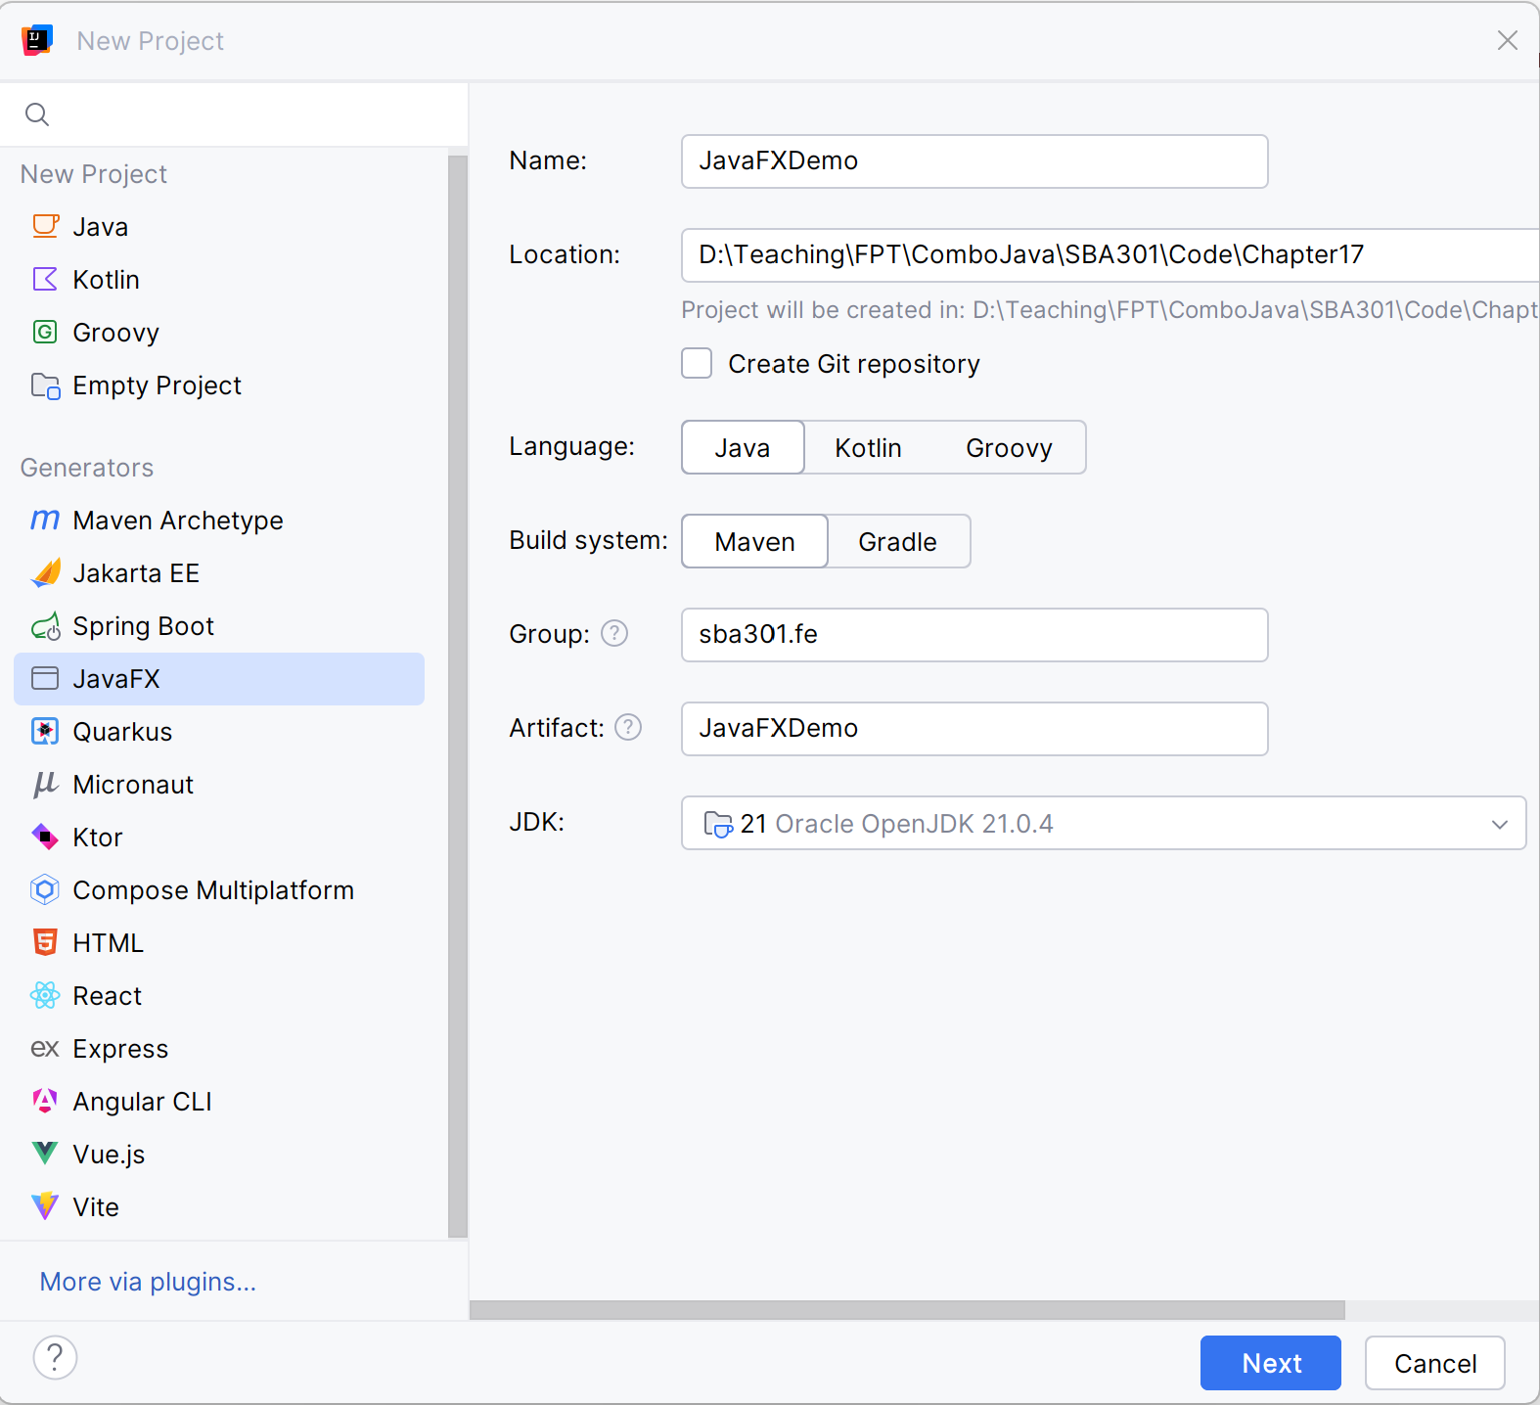

**Step 02**. Fill the Project Name

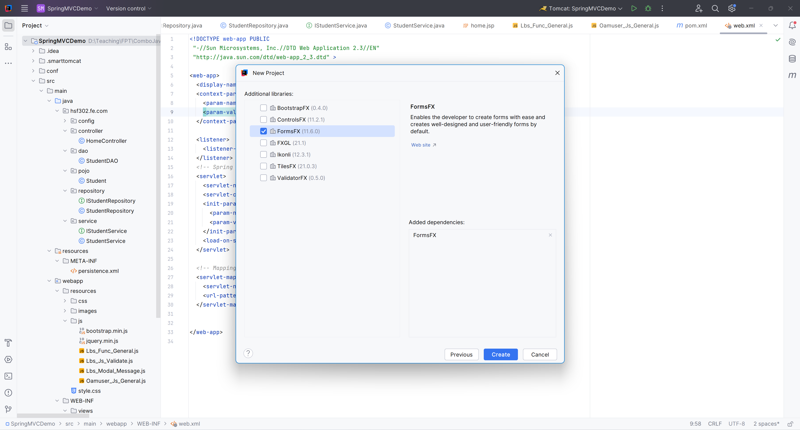

**Step 03**. Build the Architecture

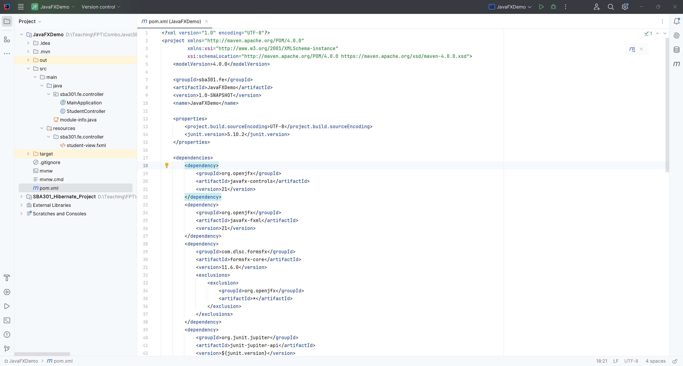

**Step 04**. Edit module.java in JavaFXDemo

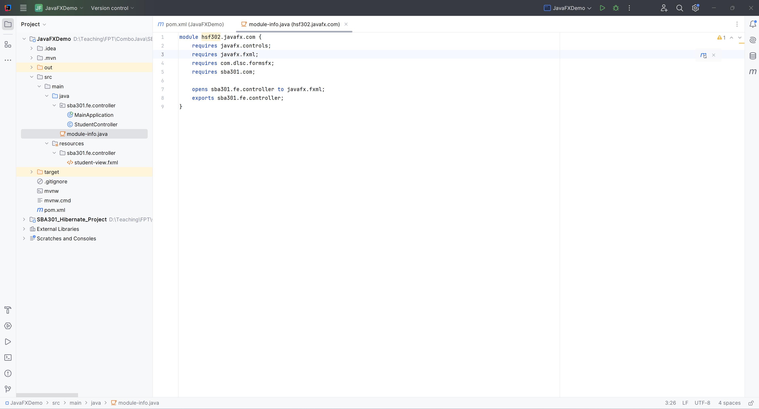

**Step 05**. Add Reference Another Project

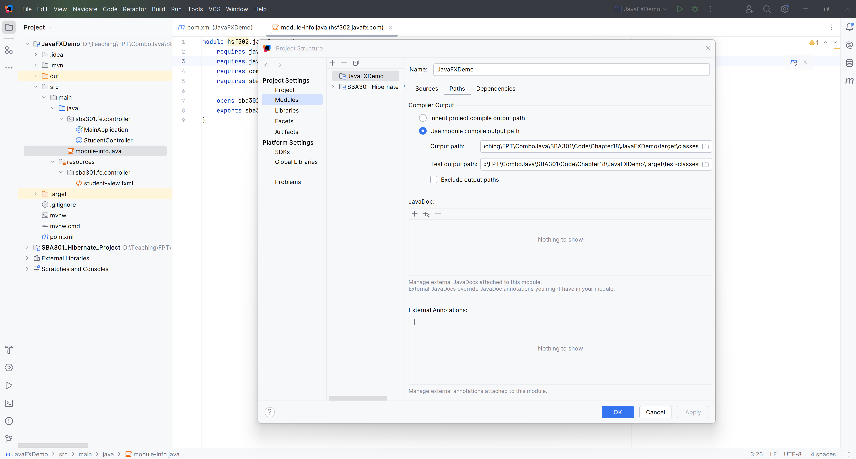

**Step 06**. Open student-view.fxml in SceneBuilder

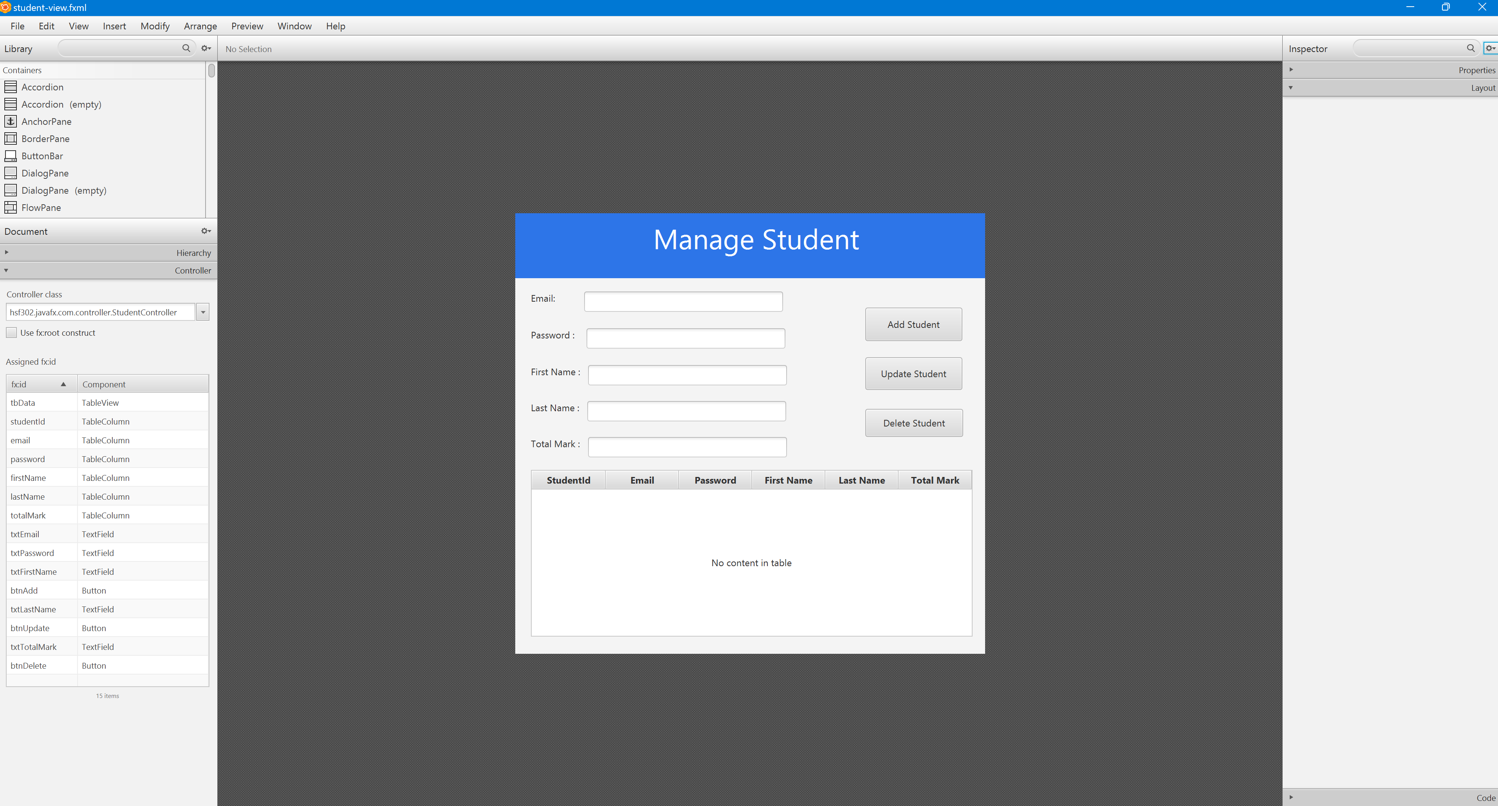

**Step 07**. Edit student-view.fxml

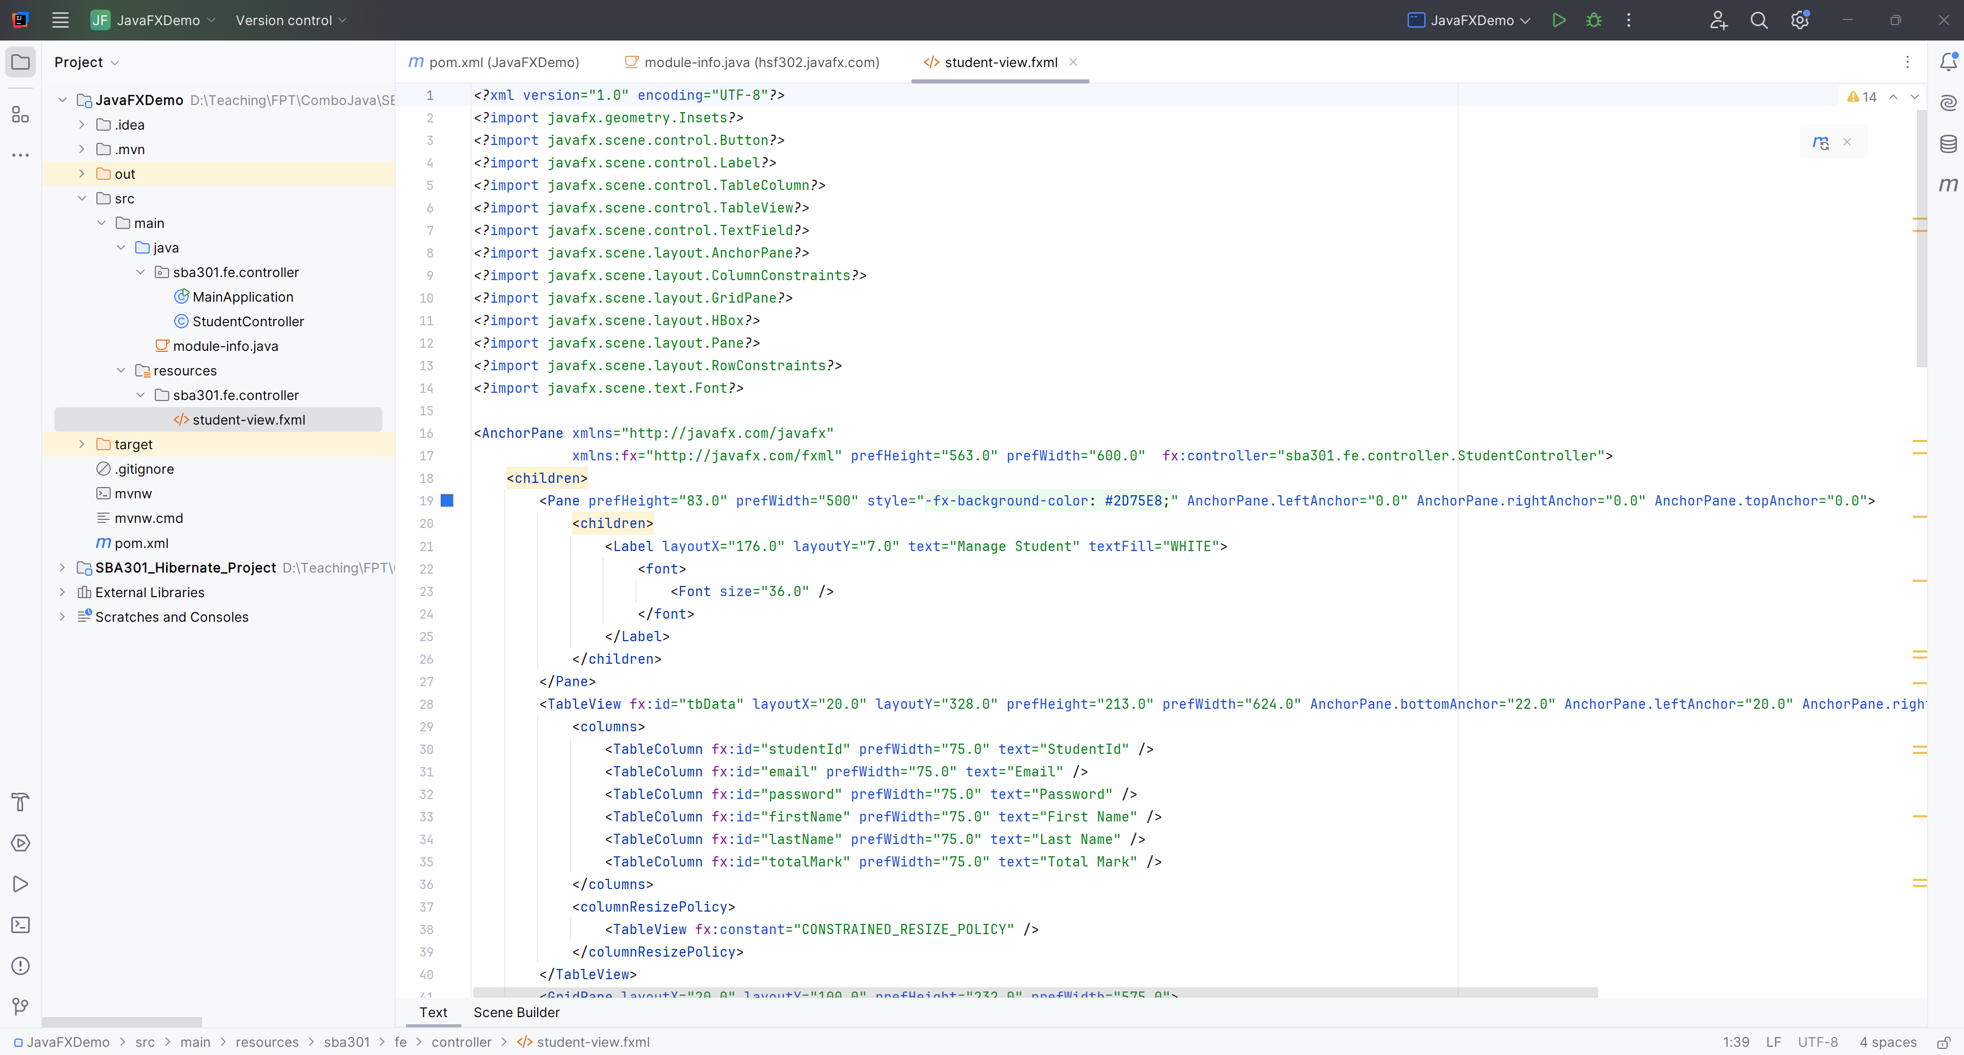

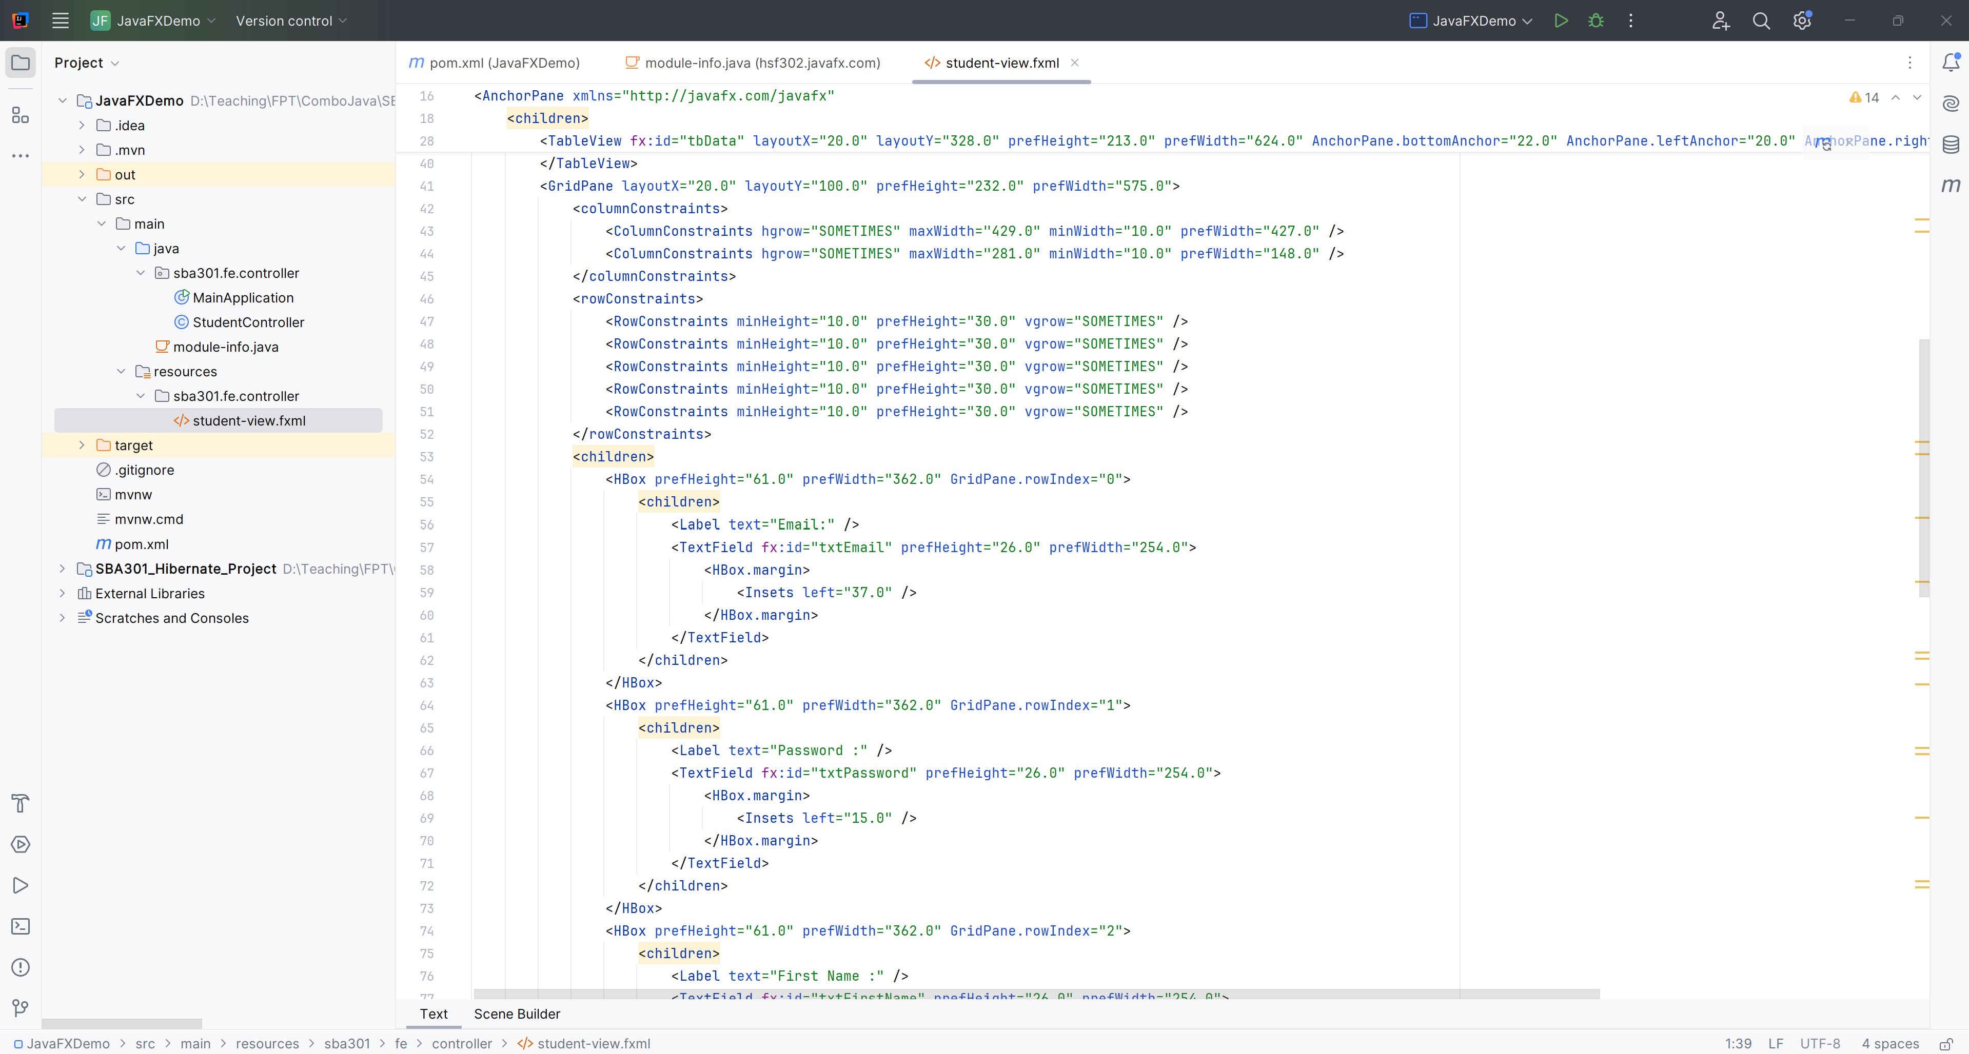

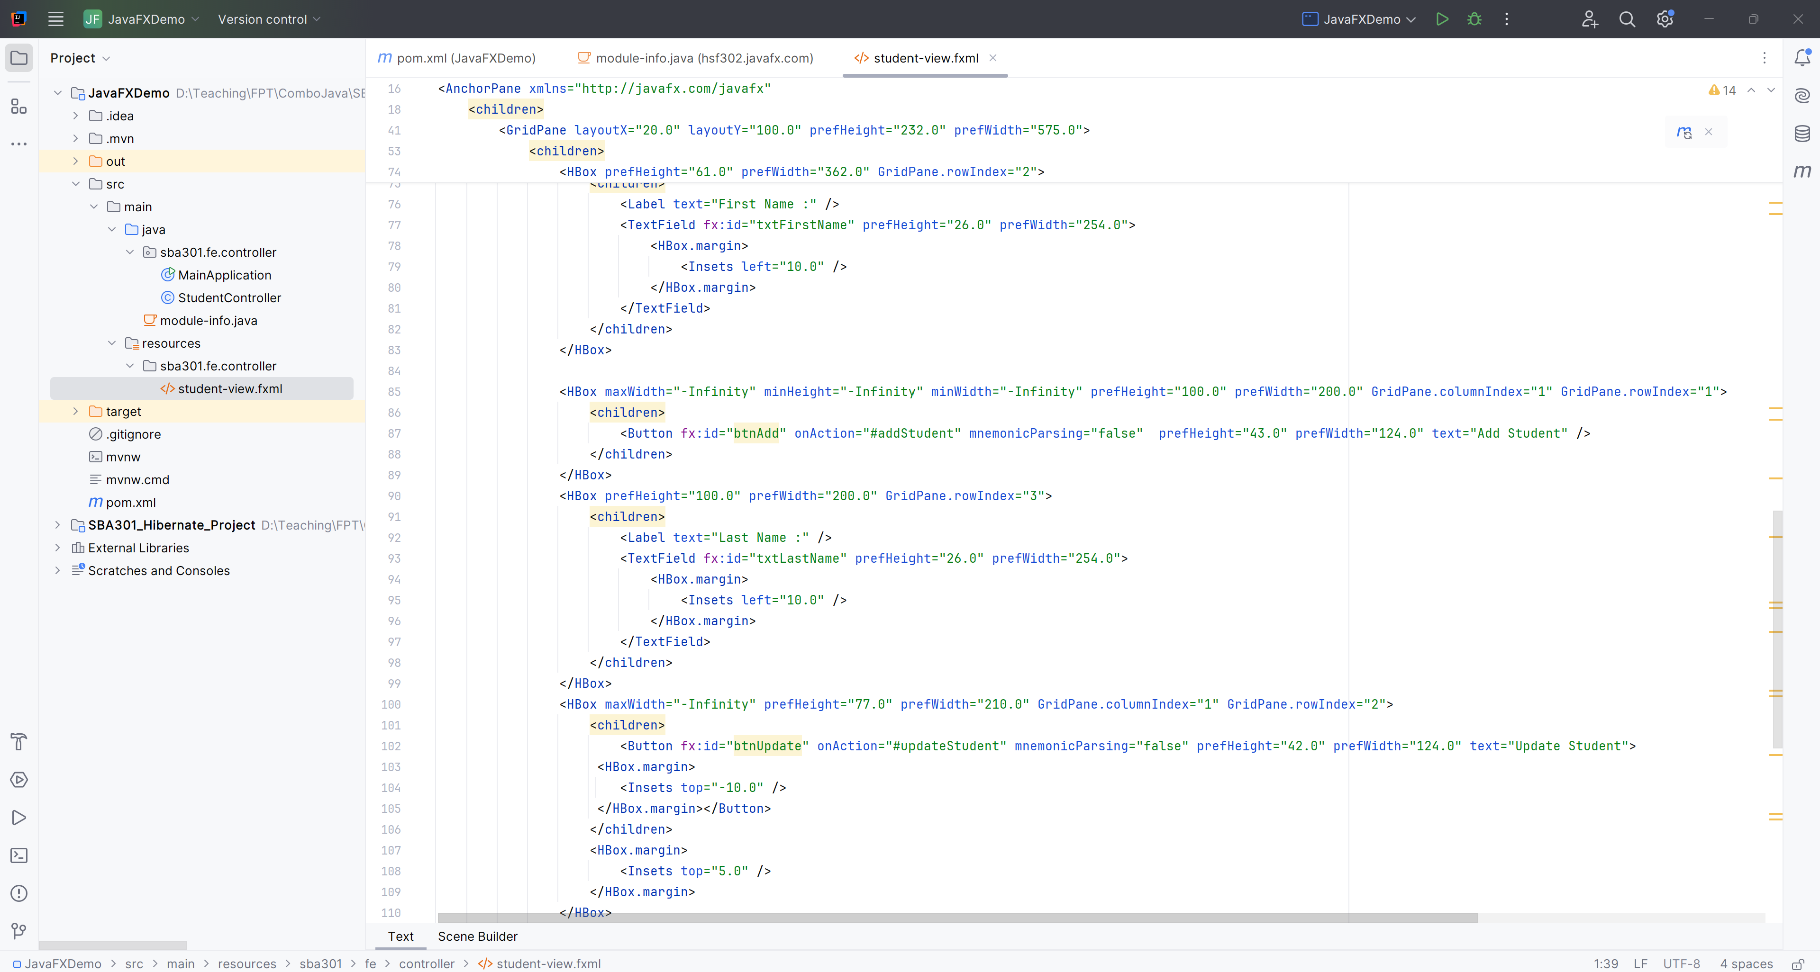

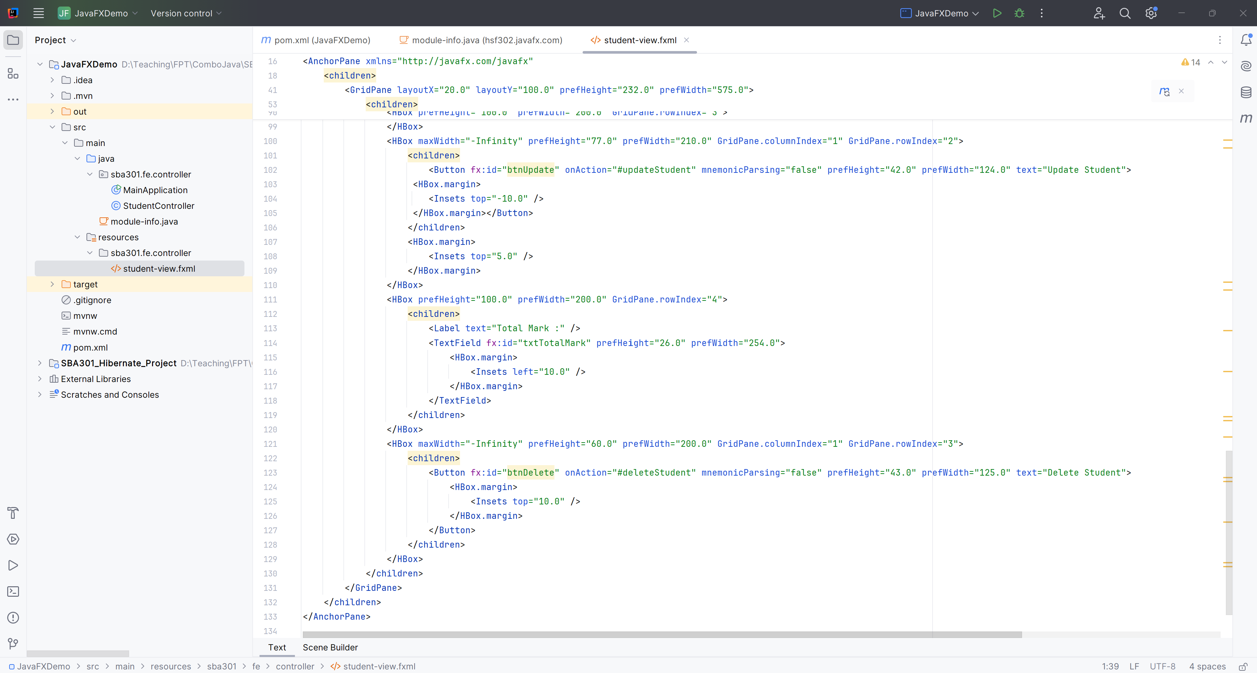

**Step 08**. Edit the StudentController.java

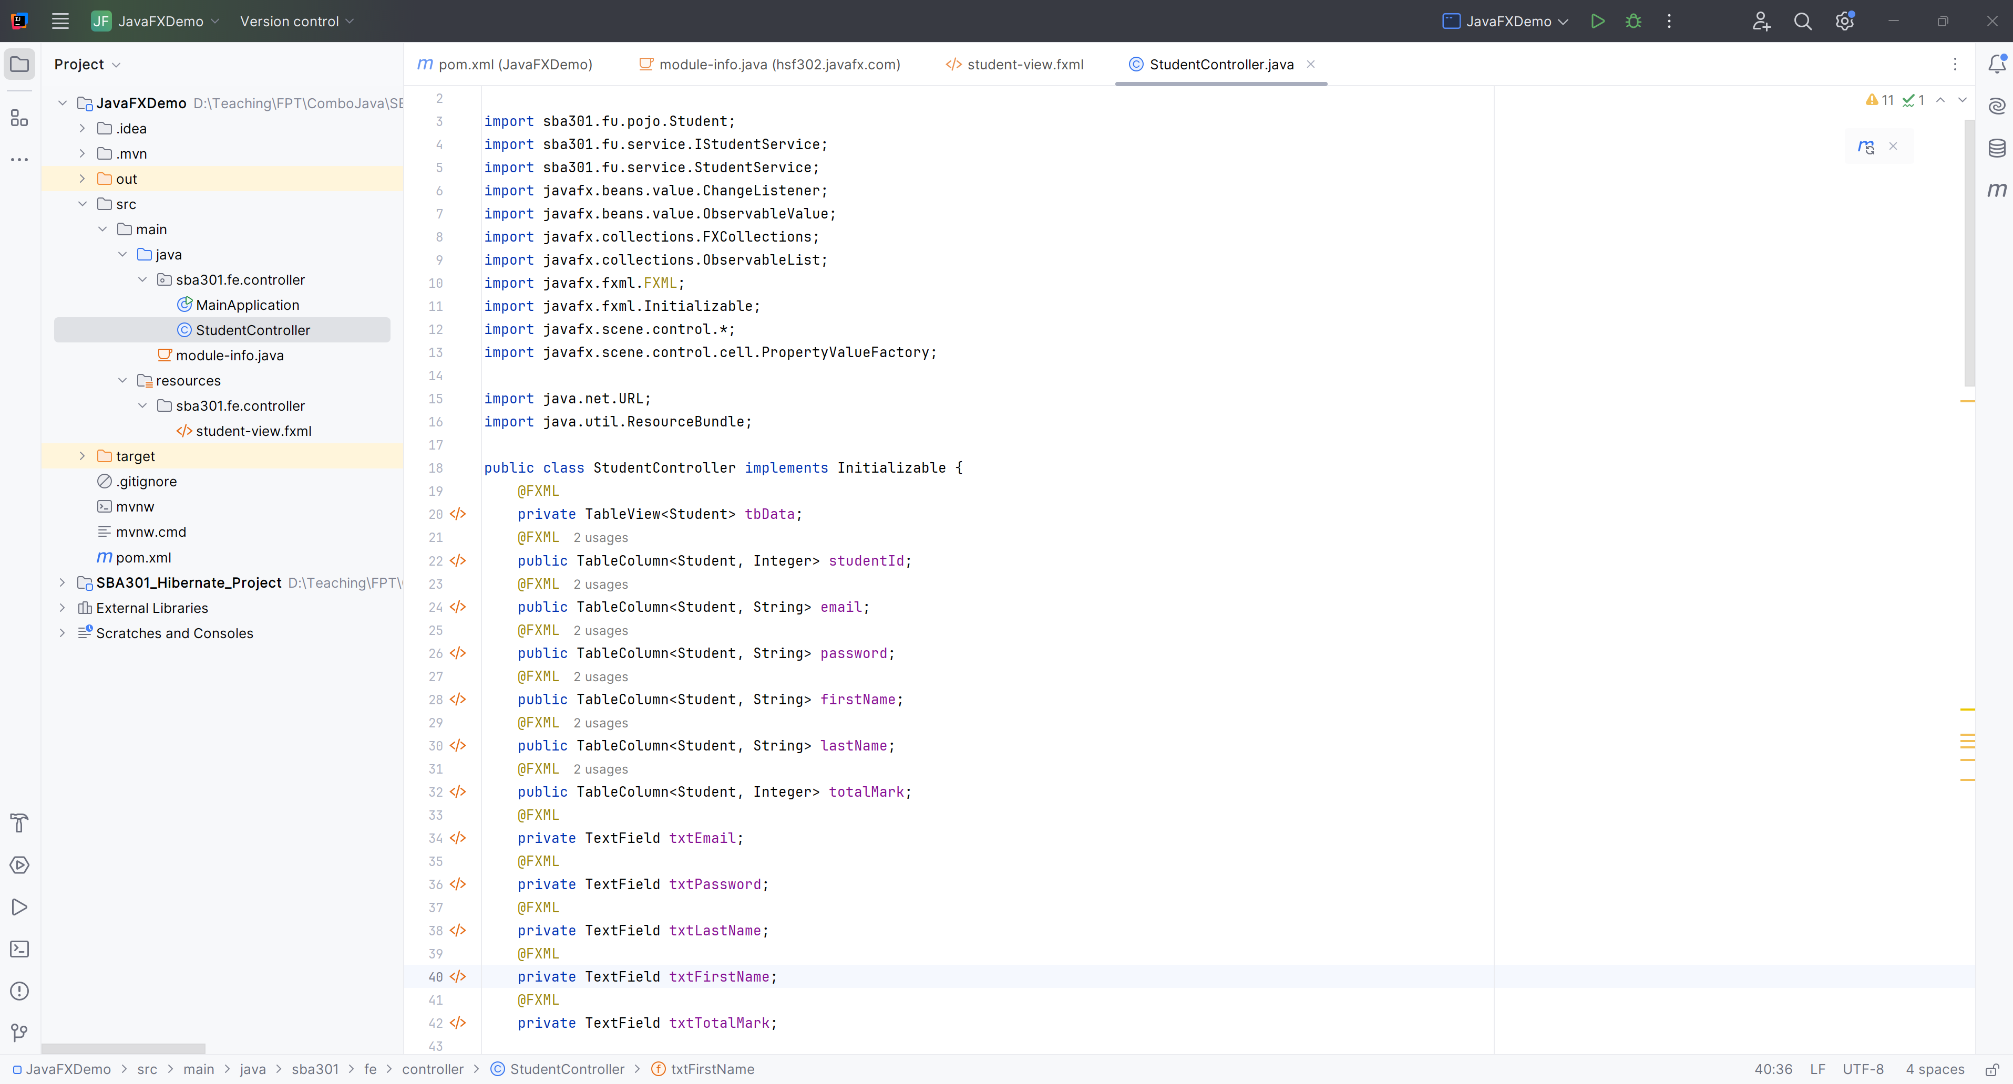

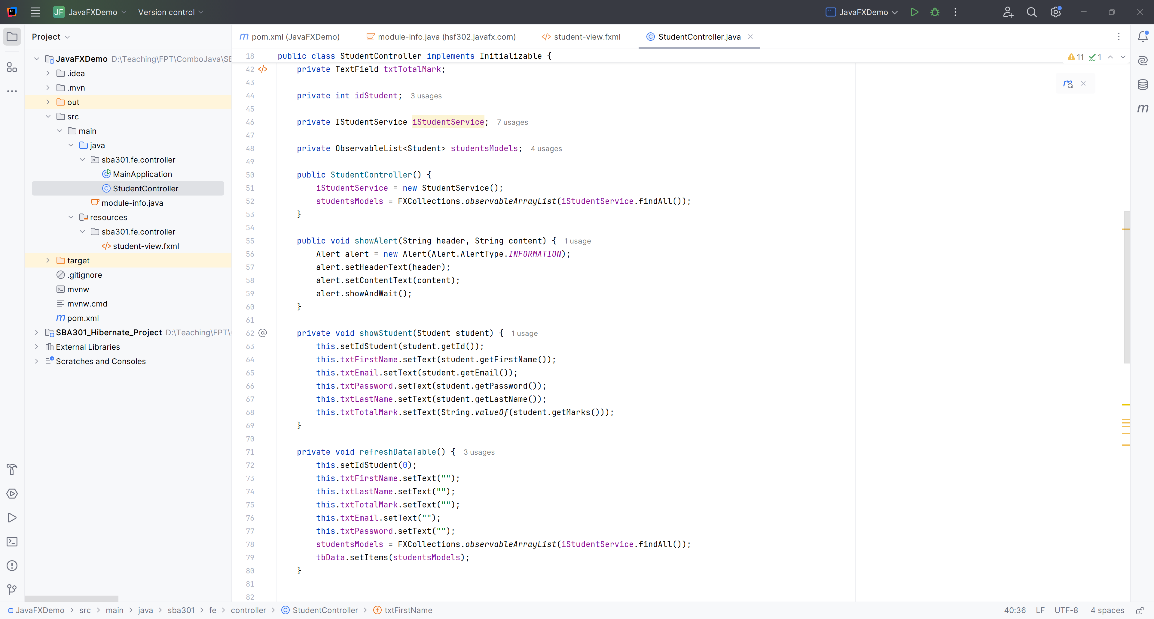

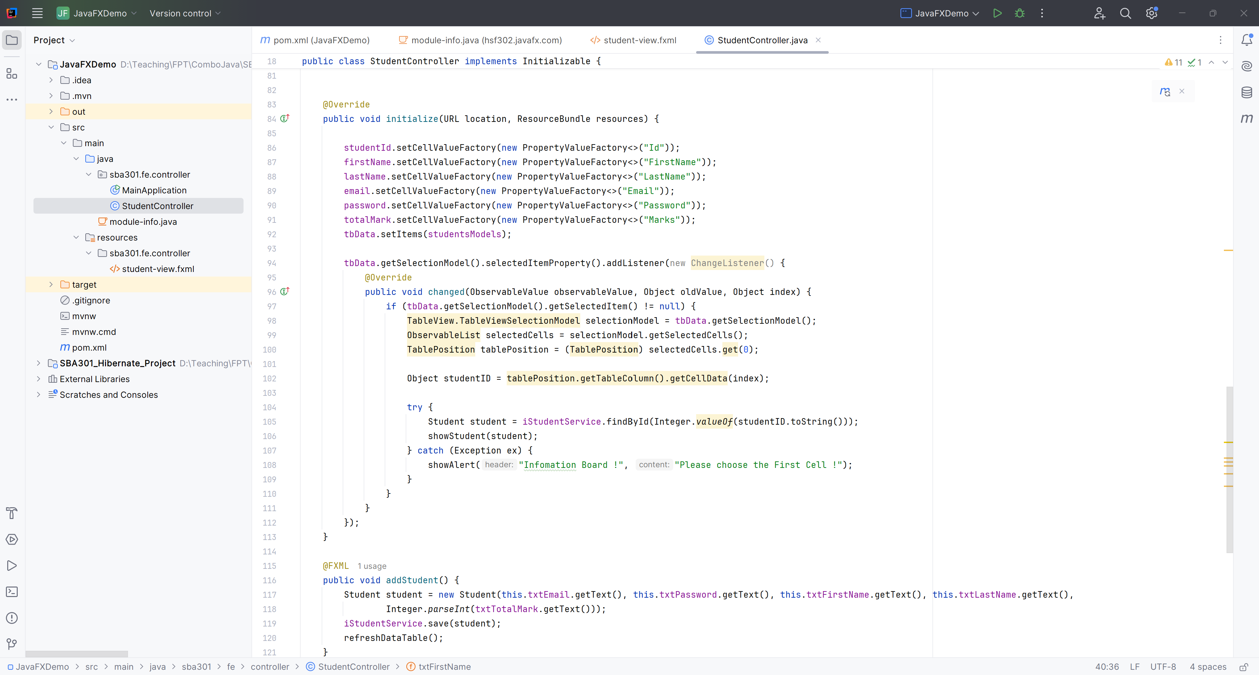

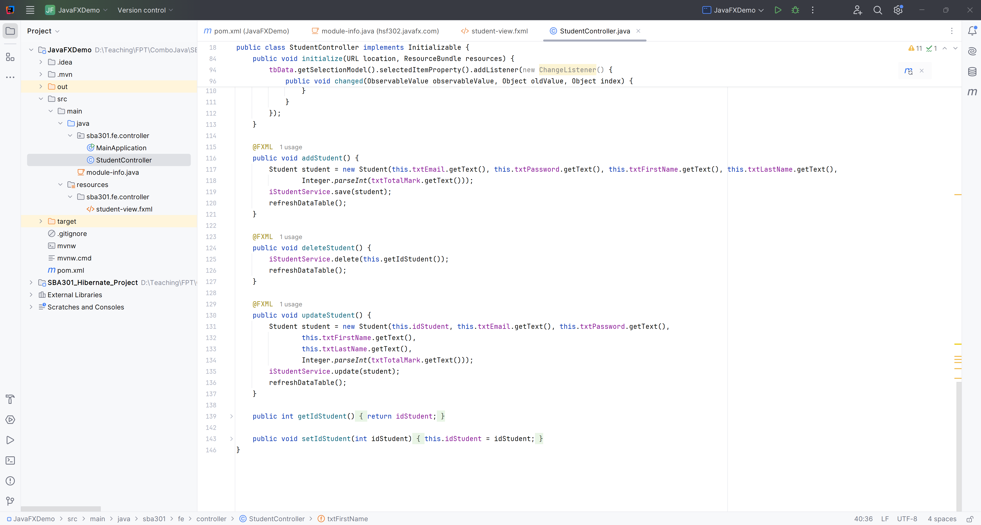

**Step 09**. Show all student and get StudentID when click first cell

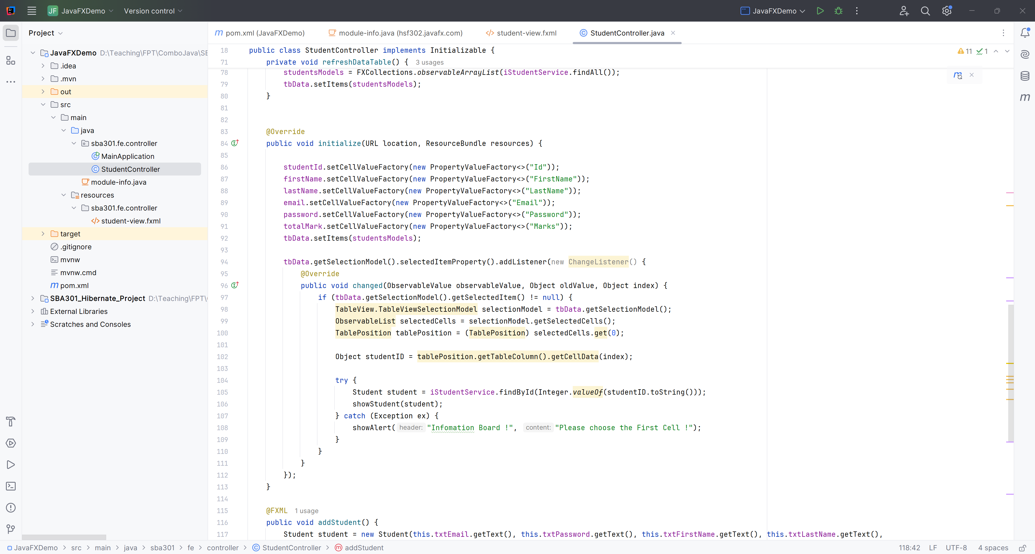

**Step 10**. CRUD for Students

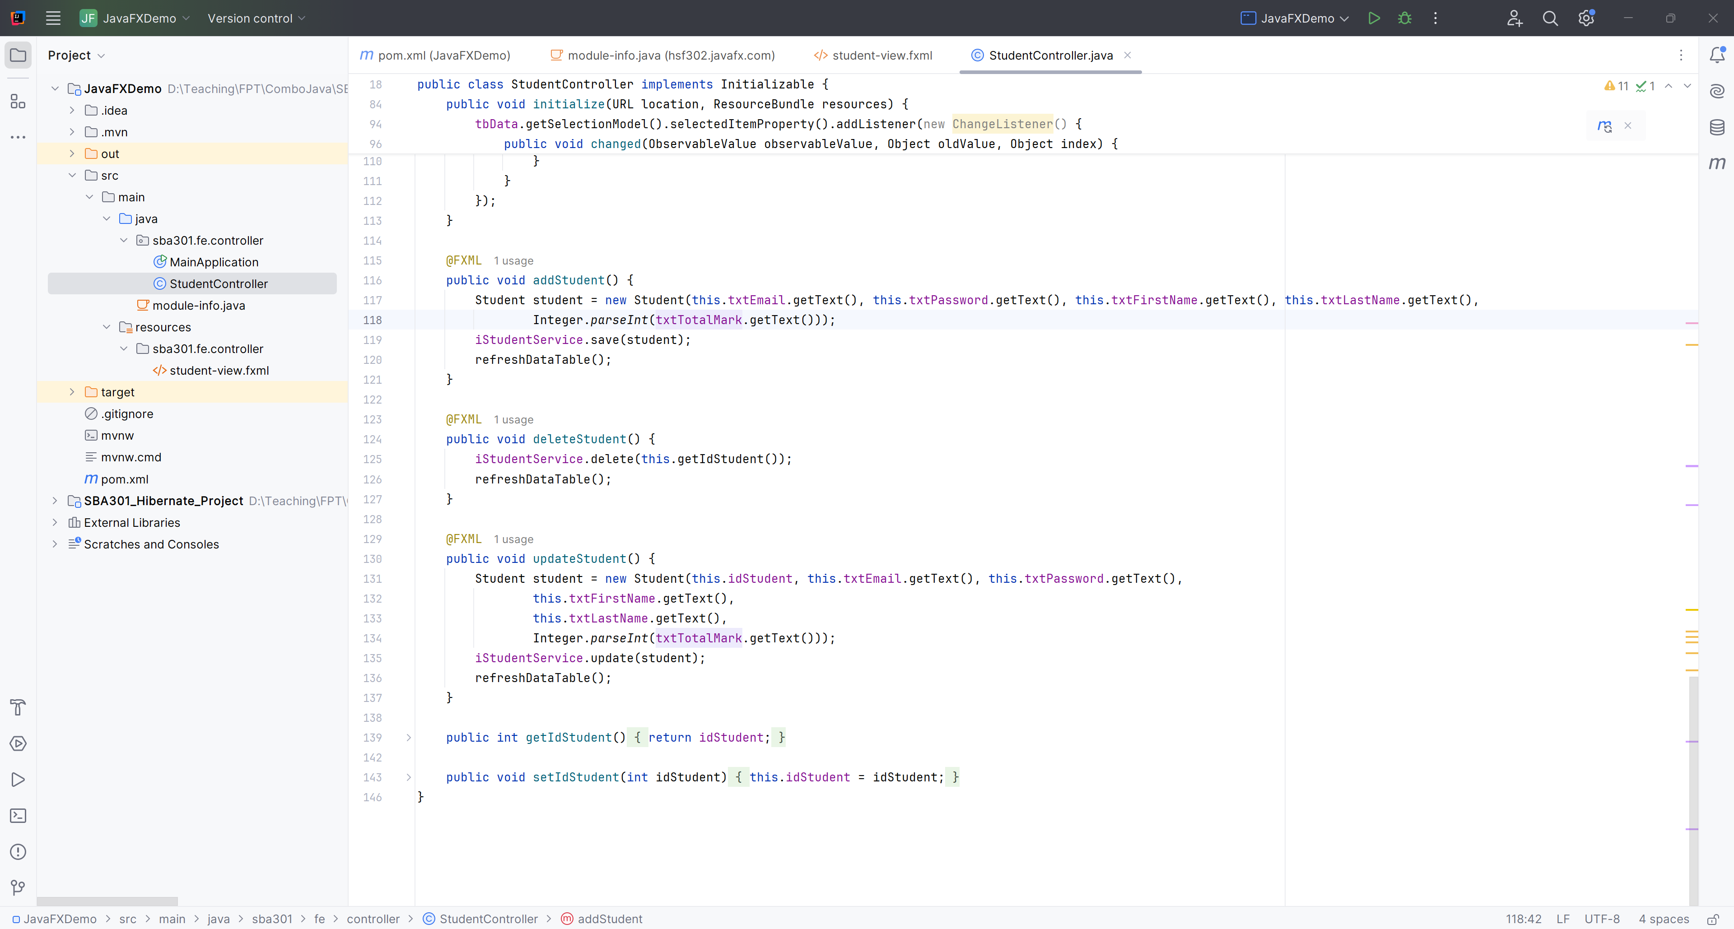

**Step 11**. Run Project

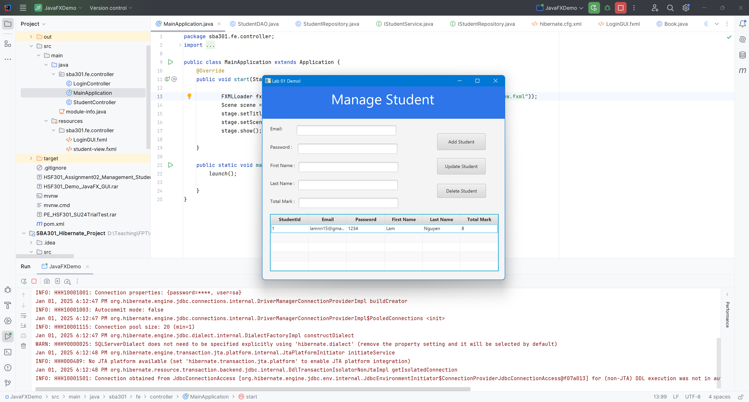

# Activity 04: Design and Develop the Login Page

**Step 01**. Design the LoginGUI.fxml

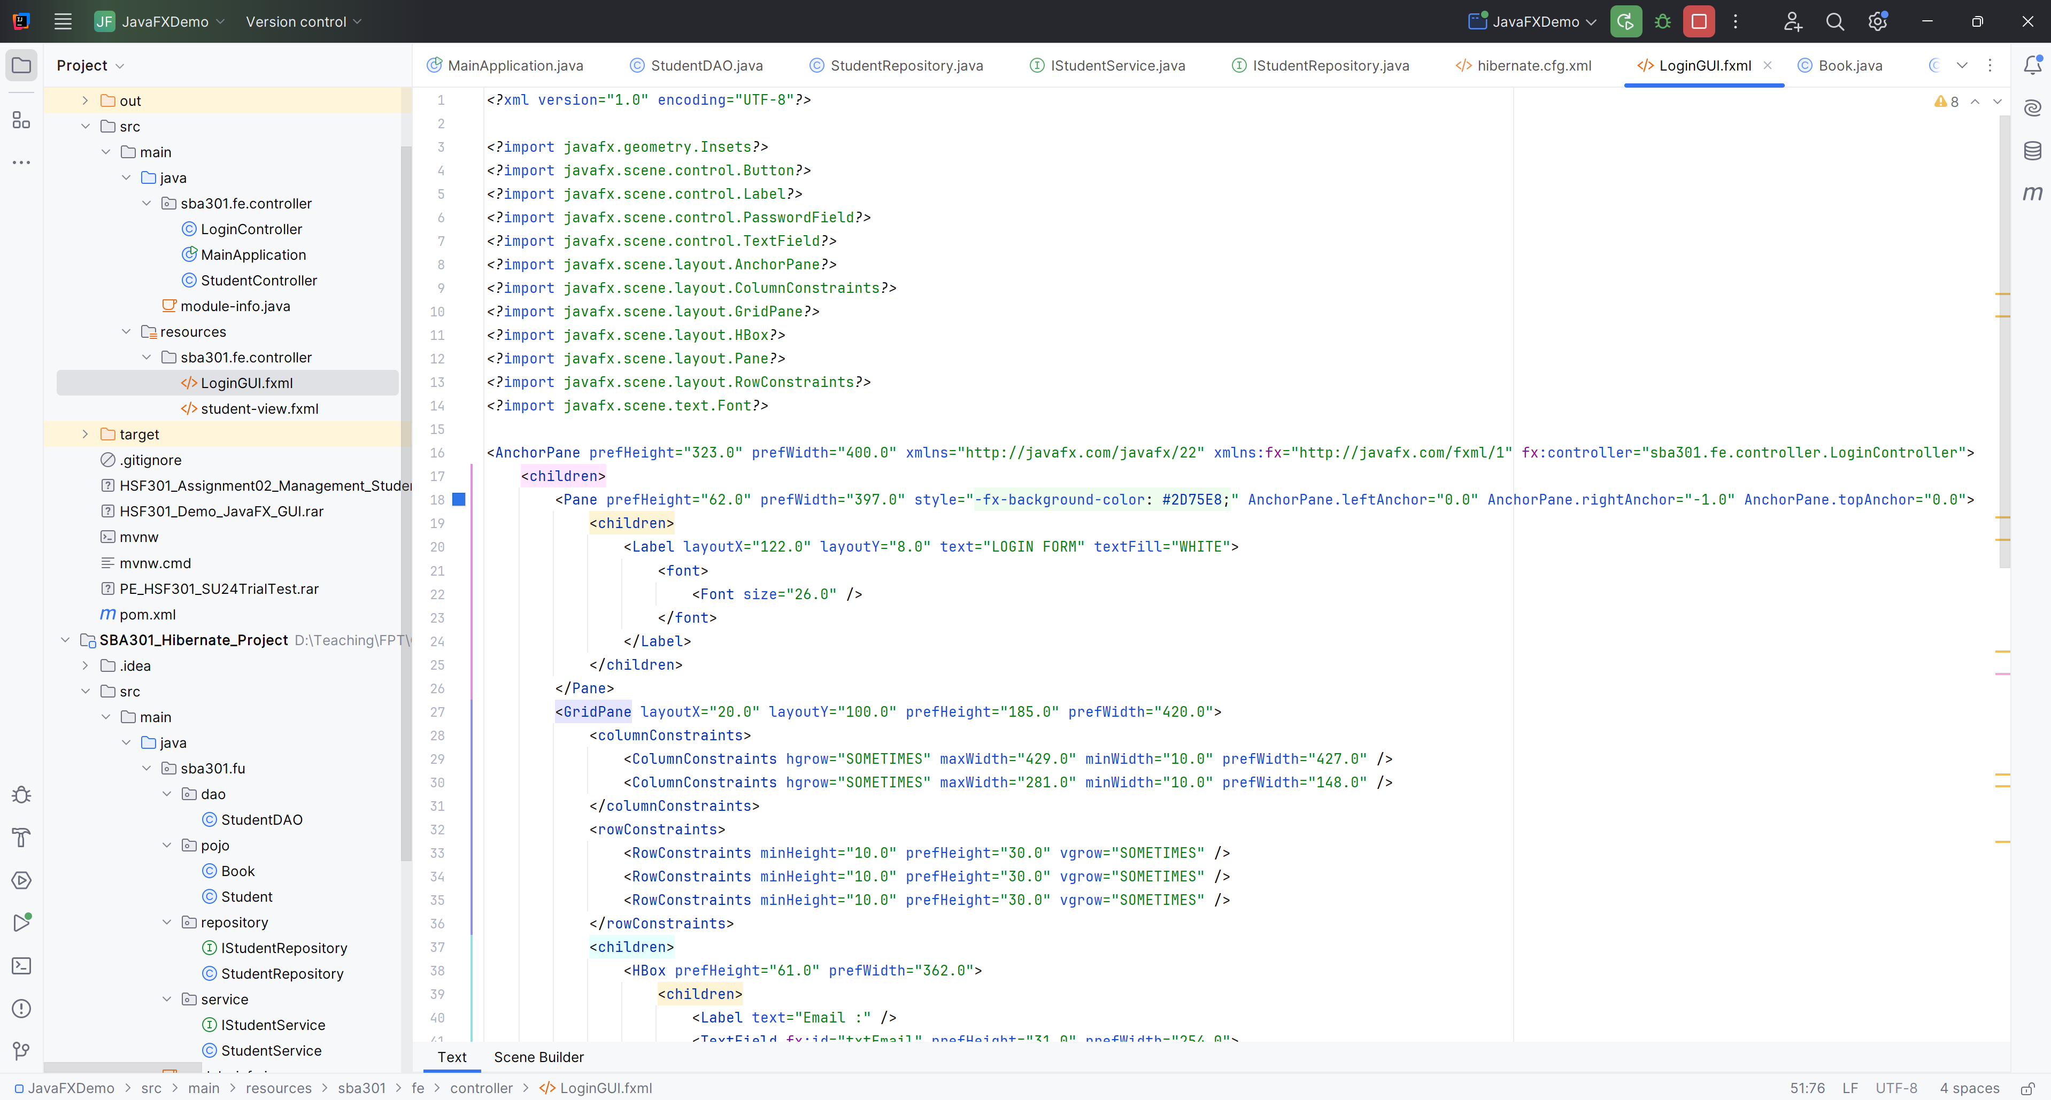

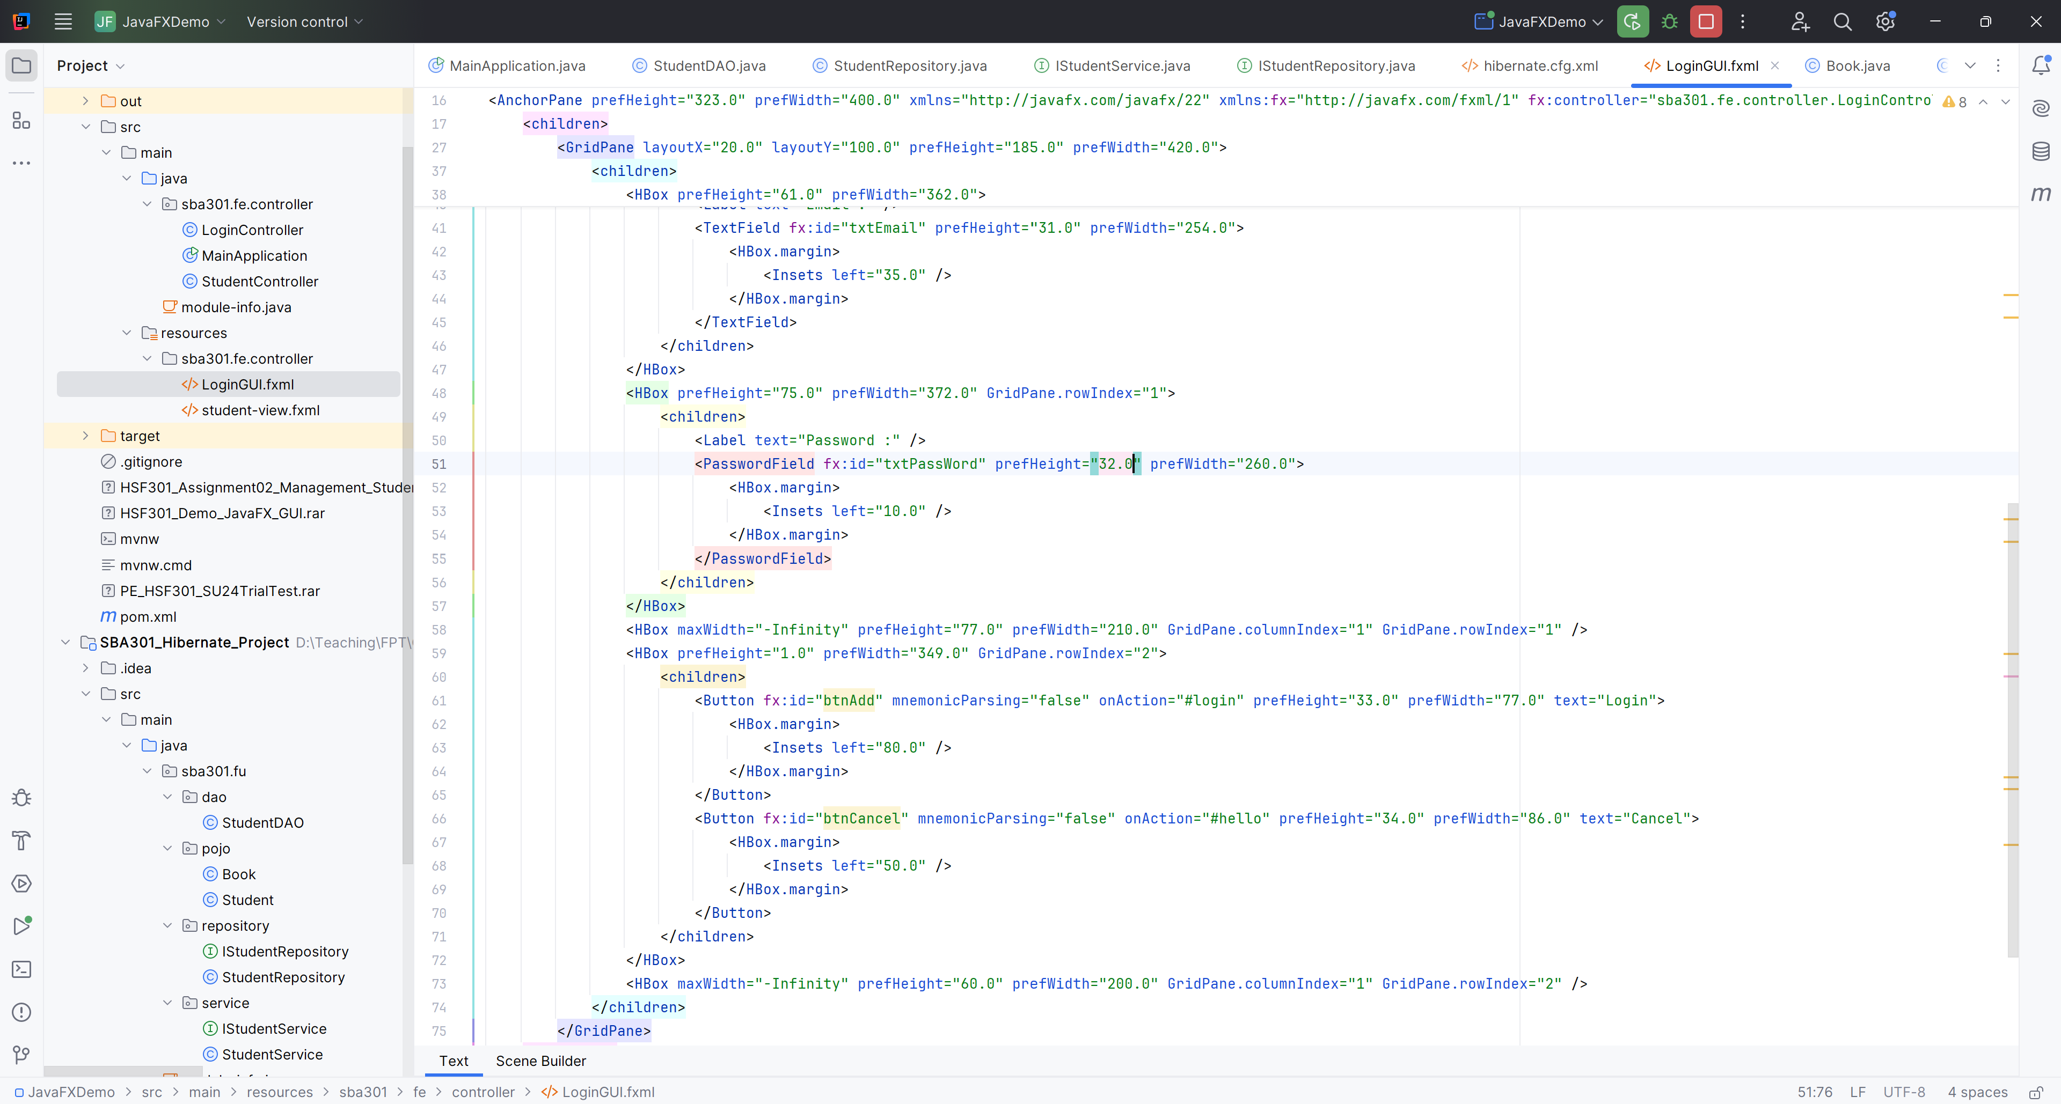

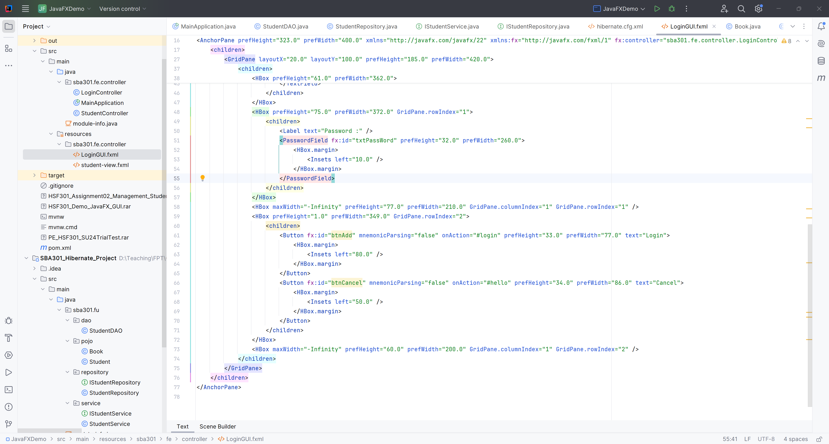

**Step 02**. Create LoginController.java in Controller Package

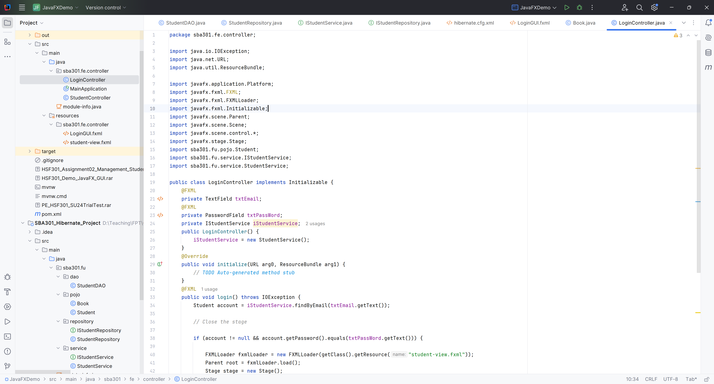

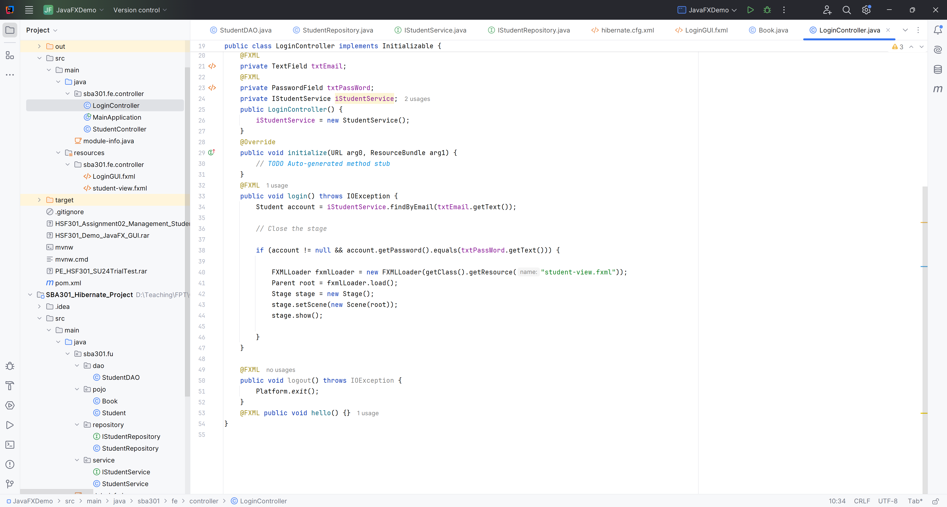

**Step 09**. Run Project  
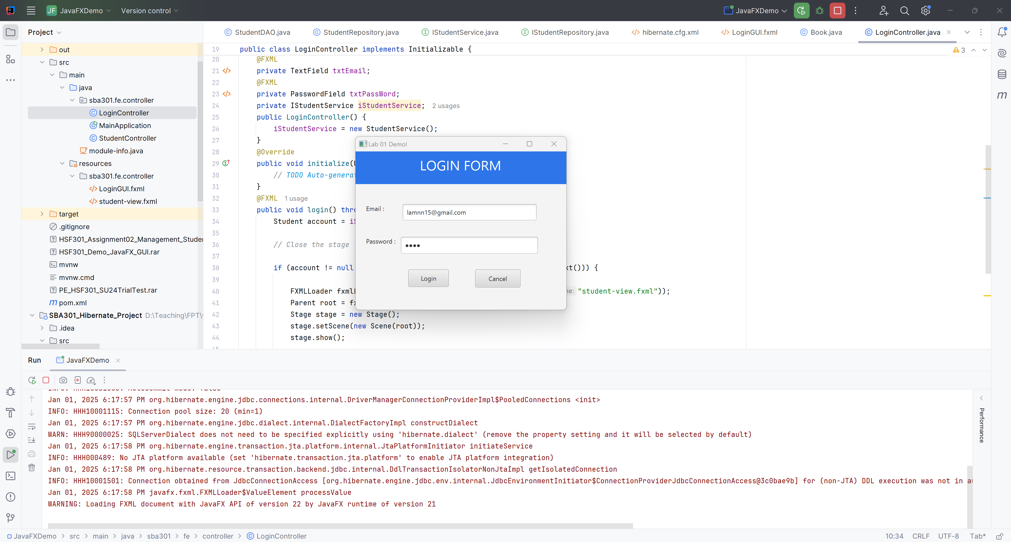

After Login Success  
